

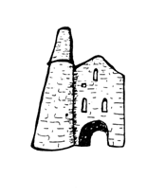**St Day and Carharrack Community School.**

77 Club

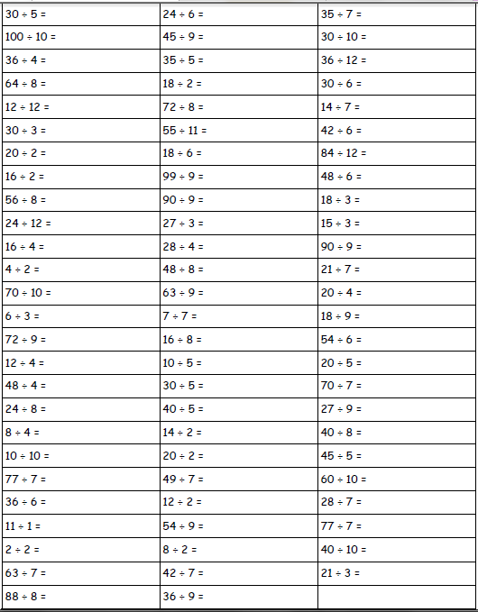Name:___________________ Date:________