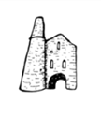 | Curriculum Map 2018-2019  Class-Topaz Year-3
 | Spring Term
Topic:  Question:  Launch:  REAL Outcome: | Do we live in the city?
 | Where do we live? What town/village? What county? What Country? What Continent?
 | A walk around our local area. Litter picking?
Publication (book-making)/Performance/ Museum/ Meal/Model… (Audience?)

Walk to Portreath Beach

Trips/Visits/Outdoors | Portreath Beach – KS2 walk to the beach – 1st June
Interactive Displays/Roleplay | Sand pit
Whole School Special Days and Festivals | Feast day  Sports day
RE: | Sikhism – A timeline. The 5 K’s of Sikhism. Explanation of the sikh symbol, Khanda.  https://www.bbc.com/bitesize/topics/zsjpyrd/resources/1  A timeline on John Wesley – walk to Gwennap pit.
PSHE/TIS: | - Golden Rules reminder  - New beginnings  - Anti-bullying week
 | BRITISH VALUES: School Council democratic elections
English:  Focus books  (linked to topic) | A range of FICTION linked to topics which develop children’s understanding of characters, plot and setting. Non-fiction: Instructions, factual reports, explanations, discussions persuasive adverts and posters.  Weeks 1 – 3 – Mousehole cat  Work based around the Mousehole cat  Weeks 4-6 – The Mermaid of Zennor  Work based around that  Weeks 7 – 9  Dead Man’s Cove – Lauren St. John  Week 10 – 13  Writing based around Cornish art by John Dyer  ERIC Term 1 – The Mousehole cat  ERIC Term 2 – Stig of the dump
Maths: | Number and place value, calculating, fractions, decimals and percentages, statistics, geometry, measure  This is not the scheme of work. White rose maths is used for guidance but is interspersed with other schemes.  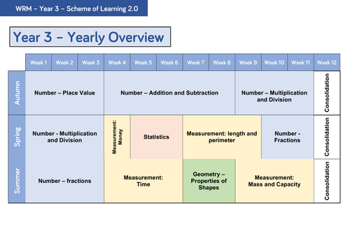  - Week 1 – Fractions – quarters/halves and three quarters – colouring in equivalents  - Week 2 – Fractions - Recognise and use fractions as numbers  - Week 3 – Fractions - Recognise and show, using diagrams, equivalent fractions with small denominators  - Week 4 – Fractions - Add and subtract fractions with the same denominator  - Week 5 - Measurement – Time - Estimate and read time with increasing accuracy to the nearest minute; record and compare time in terms of seconds, minutes and hours; use vocabulary such as o'clock, am/pm, morning, afternoon, noon and midnight  - Week 6 – Time - Estimate and read time with increasing accuracy to the nearest minute; record and compare time in terms of seconds, minutes and hours; use vocabulary such as o'clock, am/pm, morning, afternoon, noon and midnight  - Week 7 – Time - Know the number of seconds in a minute and the number of days in each month, year and leap year.  - Week 8 – Property of shape – Geometry  - Week 9 – 12 – Property of shape – Geometry/Measurement - Mass  - Week 13 – 14 – Measurement - Mass
Science: | Working Scientifically: Asking questions, setting up practical enquiries, making systematic and careful observations, taking measurements, recording findings, reporting on findings, using results to draw conclusions, using scientific evidence to answer questions  Week 2 Week 3 Week 4 Week 5 Week 6 Week 7 Week 8 Week 9 Week 10 Week 11 Week 12 Week 13  To know what nutrition means – look at how different foods help us in different ways Venn diagram – who makes their own nutrition Light - recognise that they need light in order to see things and that dark is the absence of light Light - notice that light is reflected from surfaces Investigation – have a selection of materials and see which one reflects recognise that light from the sun can be dangerous and that there are ways to protect their eyes Investigation – shadows Children put a stick outside in the morning and they measure it throughout the day Children to turn their results from last week into a graph Conclusion – what happened in their experiment? Why do you think it happened?
History: | Looking at the history of Cornwall – more specifically, the history of St Day and how it has adapted and changed over the years.
Geography: | - Looking at our local area and how to map it  - Discovering what the equator and other lines of latitude are, and what they mean.  - To be able to label European countries and colour them in the colour of their flag
Art and Design: | • Making art out of litter that we have found  • Reduce, reuse and recycle Art Posters  • Look at Cornish artists such as Alfred Wallis and recreate their work
Design Technology:  Including Cooking and Nutrition | Cooking – cooking a nutritious meal.
 | Rubbish art – use rubbish that we find to make a mosaic
Music/Drama: | • Listening to famous Cornish artists  • Practicing ceremonial dances for feast day  • Learning about sea shanties, and why they were sung
Computing: | Internet Safety: Use technology safely, respectfully and responsibly; recognise acceptable/unacceptable behaviour; Identify a range of ways to report concerns about content and contact  • Being able to establish the difference between real and fake online websites and news  • Learning new apps on the iPads such as Seesaw, which would allow for interactive lessons  • Using Scratch to create simple formulas  • Program a robot to move round a birds eye view of a map
Languages- French: | • Learn how to describe yourself, and members of your family
PE: | Introduction of real P.E. - 2 hours a week.

