|  |  |
| --- | --- |
| **balance** | **nuisance** |
| **distance** | **ambulance** |
| **performance** | **disturbance** |
| **entrance** | **tolerance** |
| **Importance** | **maintenance** |
| **appearance** | **resemblance** |
| **reluctance** | **inheritance** |
| **elegance** | **reliance** |

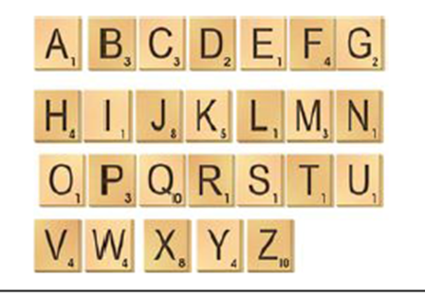

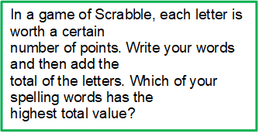

**Write your words using**

**one colour for the vowels and another colour for the consonants.**

**(vowels: a, e, i, o, u)**

**Write out your spelling words in alphabetical order and write down the word class of each word. **

**See how many times you can write your words in 2 minutes.**

**Write your spelling**

**words out in bubble writing.** 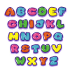

**Can you add any more ance words to our spelling list?**

**Write each word 5 times, switching the hand you write it with each time.**

**Write each of your spellings in a sentence. Can you use more than one spelling in a sentence? How many of this week’s spelling words can you use in one sentence?**





