

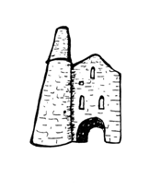**St Day and Carharrack Community School.**

66 Club

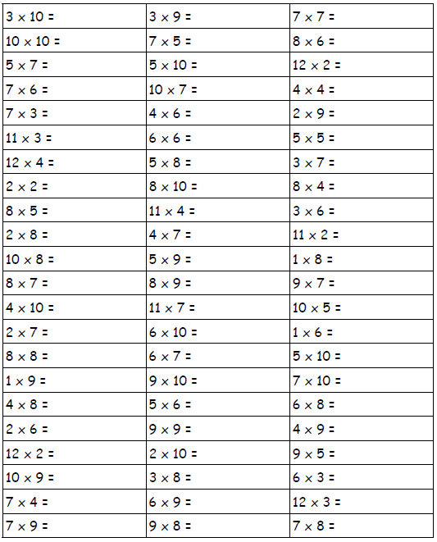Name:___________________ Date:________