

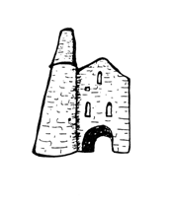**St Day and**

**Carharrack Community School.**

33 Club

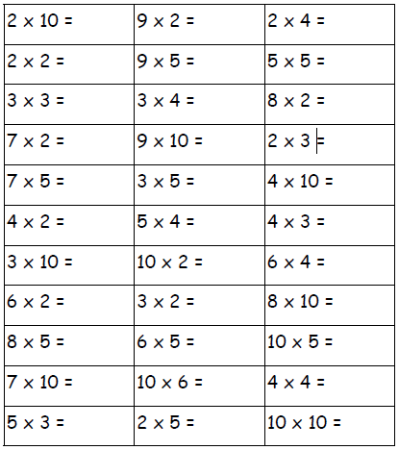Name:___________________ Date:________