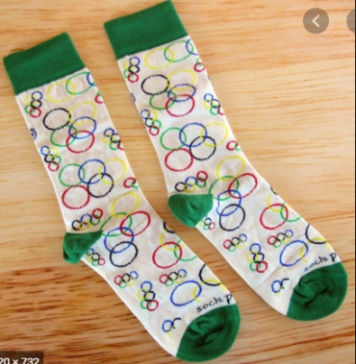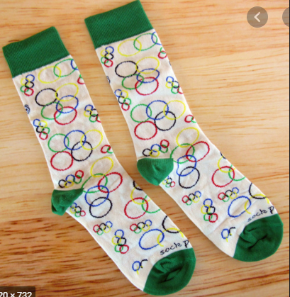

**Welcome to the**

**St Day & Carharrack School Sock Olympics!**

When you have completed the activities, **send a clear photo of your score card to**

[**msalter@stday.cornwall.sch.uk**](mailto:msalter@stday.cornwall.sch.uk)

We will send out certificates to those

who have competed in our Olympics.

This year, Sports Day is looking a little different! Due to the Tokyo 2020 Olympics being postponed until 2021, St Day & Carharrack School have planned a Sock Olympics just for you!

**You will need:**

A ball of socks!

Stopwatch/timer

Tape measure

Have a go at the different activities and record your scores on the score card!

You can see teachers demonstrating each activity on our school website!

We would also love to see any photos/videos of you completing events!

**Sock Throw**

Choose a starting position then see how far can you throw your ball of socks.

Measure your throw to the nearest cm!

Watch Mrs Salter demonstrate this on our website!

**Sock Keepy Uppies**

Can you keep your ball of socks up in the air using just your feet?

How many keepy uppies can you do in 1 minute?

Watch Frankie demonstrate this on our website!

**Sock Basketball**

Put a bucket or laundry basket 4m away. How many times can you throw your ball of socks into the bucket, collect, return and throw again in 1 minute?

Watch Miss Popperwell demonstrate this on our website!

**Sock Kneeling**

Balance a pair of socks on your head and see how many times you can kneel down and stand back up. How many can you do in 1 minute?

Watch Mrs Hicks demonstrate this on our website!

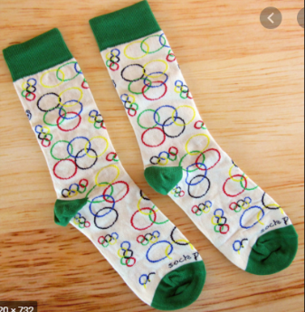

**Rainbow Sock Throw**

Put your socks into one hand & throw to your other, like a rainbow arch! How many rainbows can you throw in 1 minute?

Watch Mrs Bolt demonstrate this on our website!

**Jump In Your Socks**

You can put your socks down for this one (or put them on!). Stand still and jump as far as you possibly can!

Watch Mrs Bone demonstrate this on our website!

**Sock Jump**

Place your ball of socks on the floor and see how many times you can jump over them and back in 1 minute!

Watch Mrs Pooley demonstrate this on our website!

**Sock Bowling**

Set up 6 skittles (toilet roll tubes or empty bottles). Stand 3m away & use your ball of socks to knock them down! How many can you knock down in 3 separate throws?

Watch Miss Rogers demonstrate this on our website!

**St Day & Carharrack School**

**Sock Olympics Activity Card!**

**Sock Basketball**

How many can you score in 1 minute?

**Sock Kneeling**

How many can you do in 1 minute?

**Sock Keepy Uppies**

How many can you do in 1 minute?

**Sock Throw**

Measure to the nearest cm!



**Sock Jump**

Measure to the nearest cm!

**St Day & Carharrack School**

**Sock Olympics Score Card!**

**Name: _____________ Class: ____**

**Jump In Your Socks**

Measure to the nearest cm!

**Rainbow Sock Throw**

How many can you do in 1 minute?

**Sock Bowling**

Have 3 goes!

Your score will be out of 18!