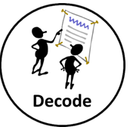 | 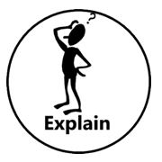 | 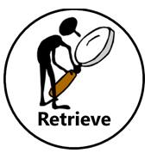 | 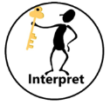
Example questions:  Do you know any other word that looks like this word?  Do you know any other words that sound like this word?  Can you find the root/suffix of that word?  Do you know any other words with the same ending?  How many syllables are in that word? | Example questions:  Who is your favourite character? Why?  Why do you think all the main characters are ___ in this book?  Would you like to live in this setting? Why/Why not?  Is there anything you would change about this story?  Do you like this text? What do you like about it? | Example questions:  What kind of text is this?  Who did ___?  Where did ___?  When did ___?  What happened when___?  Why did ____ happen?  How did ____?  How many ____?  What happened to ___? | Example questions:  Why was ____ feeling___?  Why did ____ happen?  Why did ___ say___?  Can you explain why ____?  What did you think the author intended when they said ____?  How does ___ make you feel? | Example questions:  What does the word ___ mean in this sentence?  Find and copy a word that means ___?  What does this word or phrase tell you about___?  Which word in this section do you think is the most important? Why?  Which of the words best describes the character/setting/mood etc?  Can you think of any other words the author could of used to describe this?

