

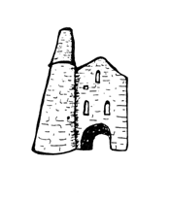**St Day and Carharrack Community School**

99 Club

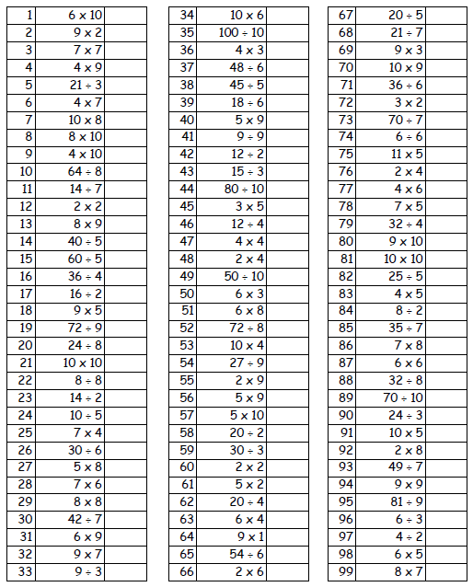Name:________________________ Date:__________________