Winter Watchlist

Here is a list of seasonal highlights from Winter Watch. You can look, listen and even smell some of the highlights.

Be inspired by nature on your daily walk. Share anything you find!

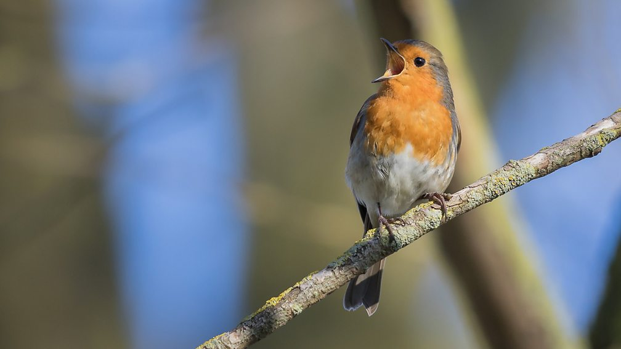

Can you hear and see a robin?

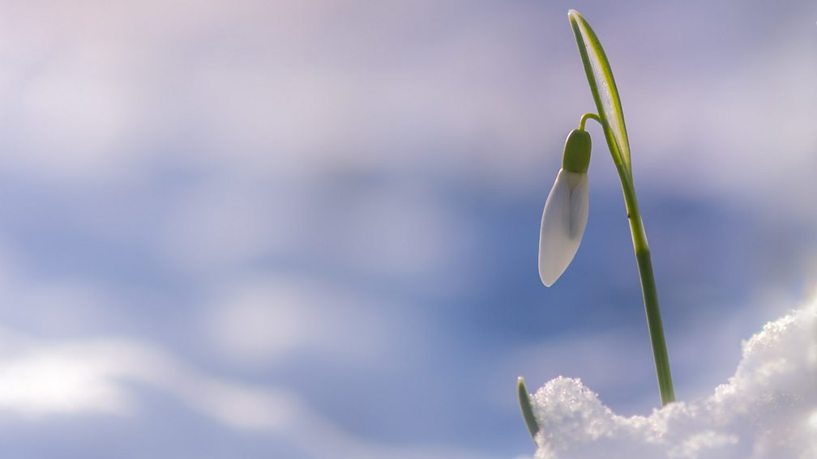

Can you spot the first snowdrops?

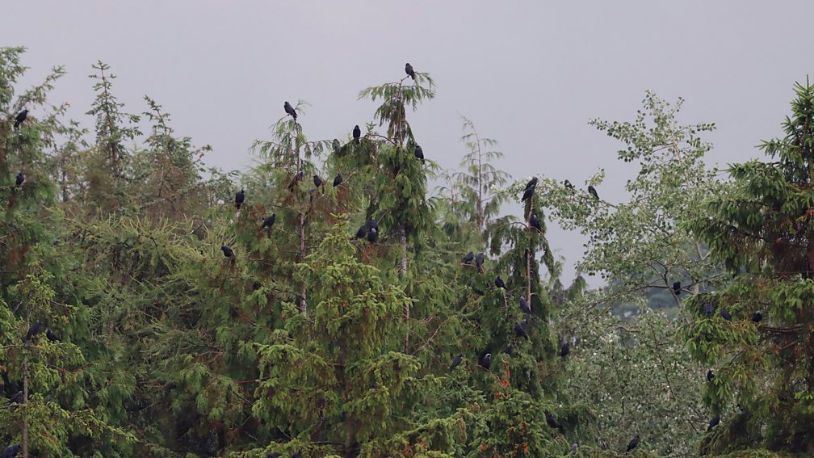

Can you see Corvids roosting?

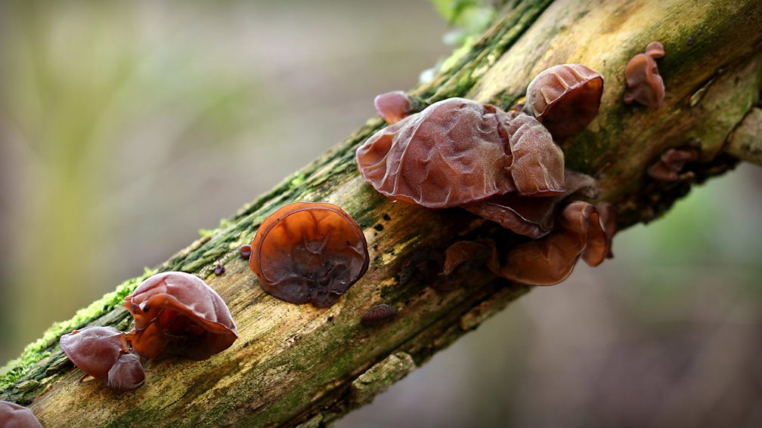

Can you find Jelly Ear/Oyster Fungus?

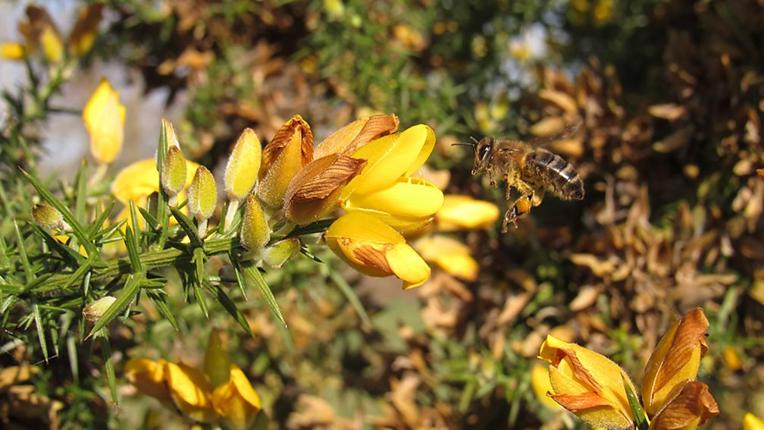

Can you smell gorse flowers?

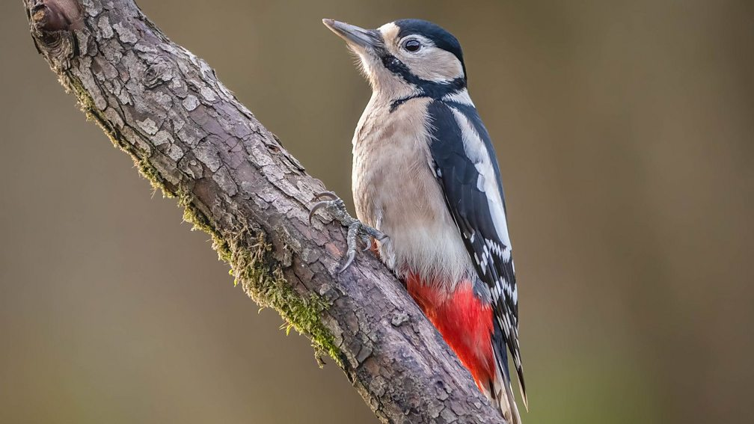

Can you hear a woodpecker drumming?

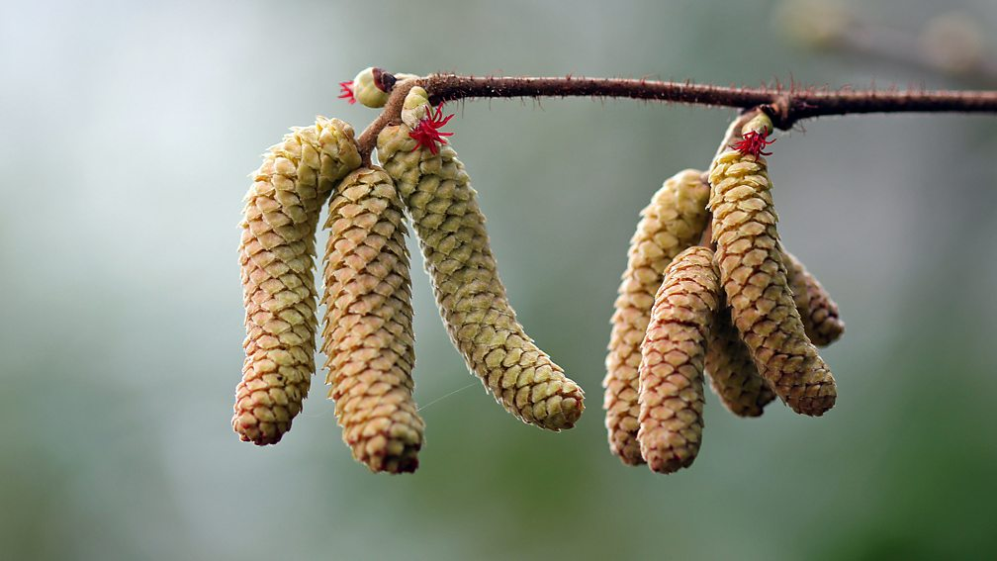

Can you spot hazel flowers?

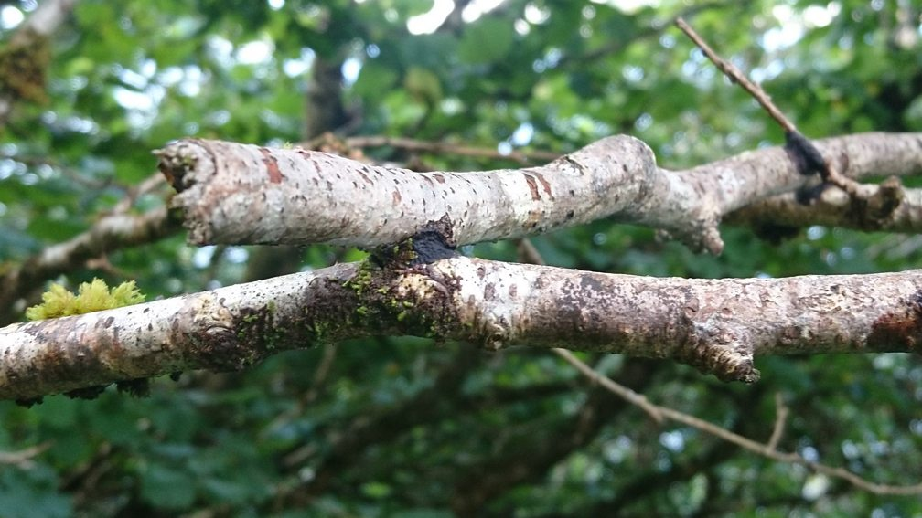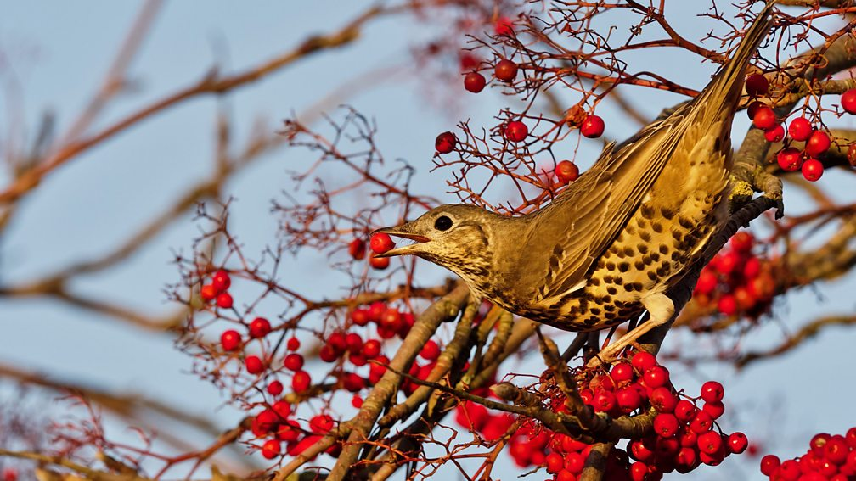

Can you find glue crust fungus?

Can you find a mistle thrush guarding berries?