Monday 7th January 2019.
Amber Class
Well done to Amber Class for your fantastic efforts with your autumn term spellings. Please find attached a summary of your spellings from last term. Please continue to practice the year 1 and year 2 common exception words which have not been highlighted.
Here are your spelling lists for the next term. Each week the children will be learning a new spelling rule which will be supported by our weekly spelling test. These are age related expectations from the National Curriculum.
If you have any questions, please feel welcome to see me at the end of the school day.
Kind regards,
Miss Peters
11.1.19  Test on:  18.1.19  -dge/g | 18.1.19  Test on:  25.1.19  s spelt with a c | 25.1.19  Test on:  1.2.19  n spelt with kn or gn | 1.2.19  Test on:  8.2.19  r spelt with wr | 8.2.19  Test on:  15.2.19  l spelt with le | 15.2.19  Test on:  1.3.19  l spelt with el | 1.3.19  Test on:  8.3.19  l spelt with al/il
badge  edge  bridge  dodge  fudge  age  huge  change  charge  village | race  ice  cell  city  fancy  face  lace  grace  circle | knock  know  knee  gnat  gnaw  knew  knitting  gnarl  gnash  knife | write  written  wrote  wrong  wrap | table  apple  bottle  little  middle  topple | camel  tunnel  squirrel  travel  towel  tinsel  bagel  hazel  vowel  jewel | metal  pedal  capital  hospital  animal  oval  pencil  fossil  nostril  pupil

8.3.19  Test on:  15.3.19  y | 15.3.19  Test on:  22.3.19  es to nouns and verbs ending in y. | 22.3.19  Test on:  29.3.19  ed, er,est, ing
cry  fly  fry  dry  try  reply  July  Sly  Shy  terrify | flies  tries  replies  copies  babies  carries | copied  copier  happier  happiest  cried  replied  tried  copying  crying  replying
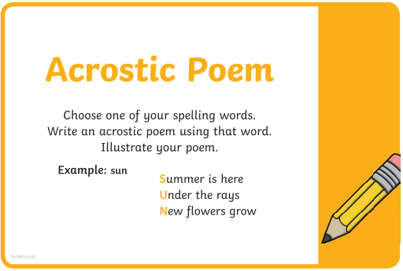
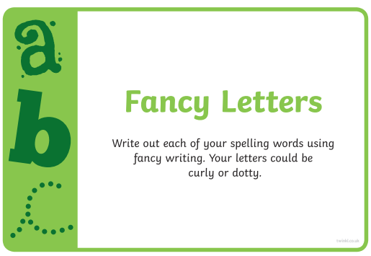
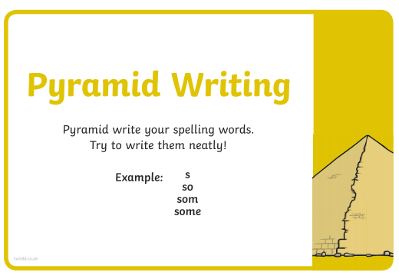
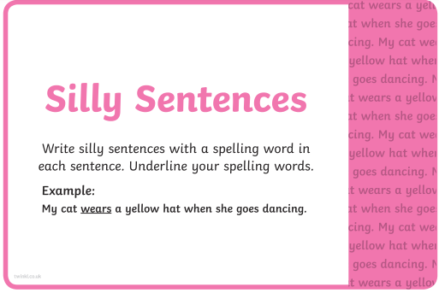
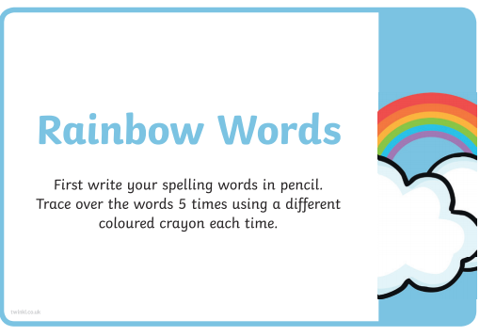
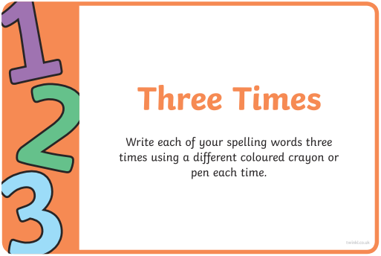
Here are some spelling activities and strategies you can do at home:
