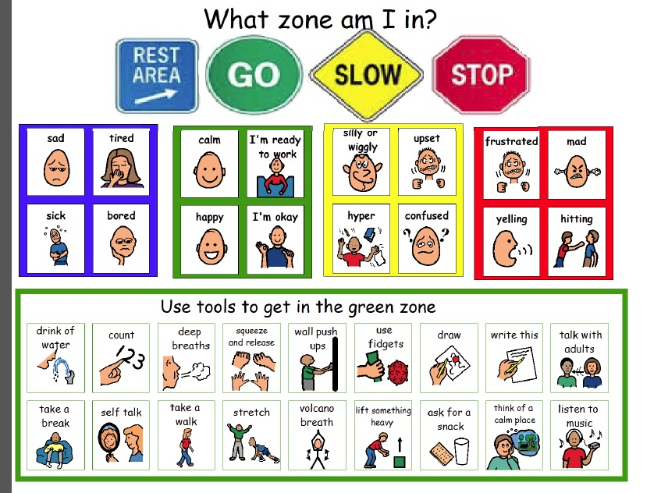
The Zones of Regulation… leading to self regulation
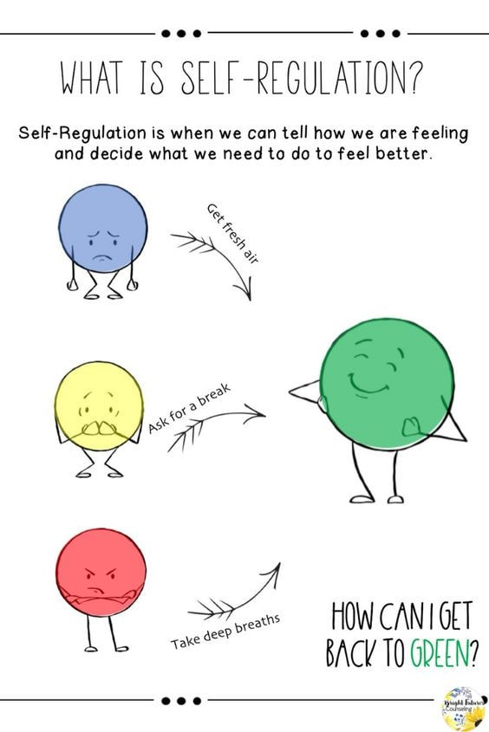
The Zones of Regulation teach students how to identify and regulate their emotions. It is a cognitive behaviour approach for helping students self-regulate their behaviours, emotions, and sensory needs. By using concepts and visuals to help students learn to recognise their feelings and level of arousal, it allows them to employ strategies for emotional control and optimal learning. Students practice identifying their emotion and then identify the tools that they can use to "get back to the green zone". The green zone is when we are best able to learn. Children also learn to analyze how big a problem is and what the appropriate reaction would be.
For an overview, watch two short clips:
https://figur8.net/2016/06/12/self-regulation-and-the-zones-of-regulation/

The Goals of the Zones of Regulation are to teach children to:

- identify their feelings and levels of alertness
- develop effective regulation tools
- learn when and how to use the tools
- problem solve positive solutions
- understand how their behaviours influence thoughts and feelings
- ultimately – develop independent regulation

The Four Zones of Regulation

- Blue Zone: low level of arousal; not ready to learn; feels sad, sick, tired, bored, moving slowly.
- Green Zone: calm state of alertness; optimal level to learn; feels happy, calm, feeling okay, focused.
- Yellow Zone: heightened state of alertness; elevated emotions; has some control; feels frustrated, worried, silly/wiggly, excited, loss of some control.
- Red Zone: heightened state of alertness and intense emotions; not an optimal level for learning; out of control; feels mad/angry, terrified, yelling/hitting, elated, out of control.

What Zone are You in?

- Blue Zone – your body is running slow, like when you’re tired, sick, sad or bored.
- Green Zone – like a green light, you feel “good to go”. Your body may feel happy, calm and focused.
- Yellow Zone – when you start to lose control, like when you feel frustrated, anxious, worried, silly or surprised. Use caution when you are in this zone.
- Red Zone – when you experience extreme emotions. When you are in this zone, you are out of control, you have trouble making good decisions, and you need to STOP!

What is Self-Regulation?
Self–regulation is the ability to manage disruptive emotions and impulses, and to think before you react. In school, children need to be able to self-regulate to help them be ready to learn. Children whose states of arousal are too high or too low will struggle to focus on the learning task at hand.

Children who are unable to self-regulate are prone to the following:
- tantrums and outbursts
- abusive behaviours – e.g. self abuse, punching, kicking, biting
- emotional distress
- inattention/distractibility
- refusal to participate

How can we help children learn self-regulation?
To help children learn self-regulation, we need to work on their:

- executive functioning – memory, planning and behaviour inhibition.
- emotional regulation – initiating, inhibiting, or modulating our state or behavior in a given situation.
- sensory integration – the process by which we receive information through our senses, organise this information, and use it to participate in everyday activities.

The Zones can be compared to traffic signs. When given a green light or in the Green Zone, one is “good to go”. A yellow sign means be aware or take caution, which applies to the Yellow Zone. A red light or stop sign means stop, and when one is the Red Zone, this often is the case. The Blue Zone can be compared to the rest area signs where one goes to rest or re-energize. Although the Zones of Regulation is often used to support the needs of children with ASD or ADHD, it is very much applicable to all children, and even adults. The ability to recognise our own state of arousal and to make the necessary adjustment so that it is appropriate for the occasion we face is something we all require to function optimally.

For the Red Zones- decrease arousal:
- take three deep breaths
- the size of your reaction should match the size of the problem
- jump on a trampoline
- relax your muscles
- talk to an adult
- sensory break
- push the wall
- walk away
- STOP!
- deep pressure
- slow movement
- heavy work to muscles
- soft lighting
- listen to music
- chewy foods

For the Yellow – decrease arousal:
- talk to my parents/friends
- take 3 deep breaths
- do a wall push up
- use a fidget
- go for a walk
- take a break
- read
- deep pressure
- slow movement
- heavy work to muscles
- soft lighting
- listen to music
- chewy foods

For the Green Zone – maintaining:
- keep your eyes on the teacher
- remember your daily goals
- finish your homework
- think happy thoughts
- be a good friend
- help others
- work hard
- smile

For the Blue Zone – increase arousal:
- think happy thoughts
- talk about your feelings
- rub hands together
- run on the spot
- shoulder rub
- ask for a hug
- swinging or spinning
- stretching or jumping jacks
- strong scents
- vibration
- drink water
- crunchy foods
- bright lights
- listening to loud music

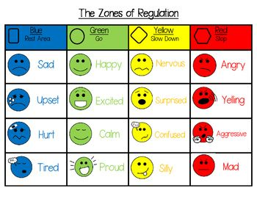
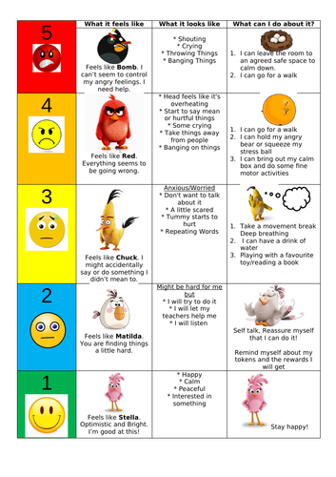
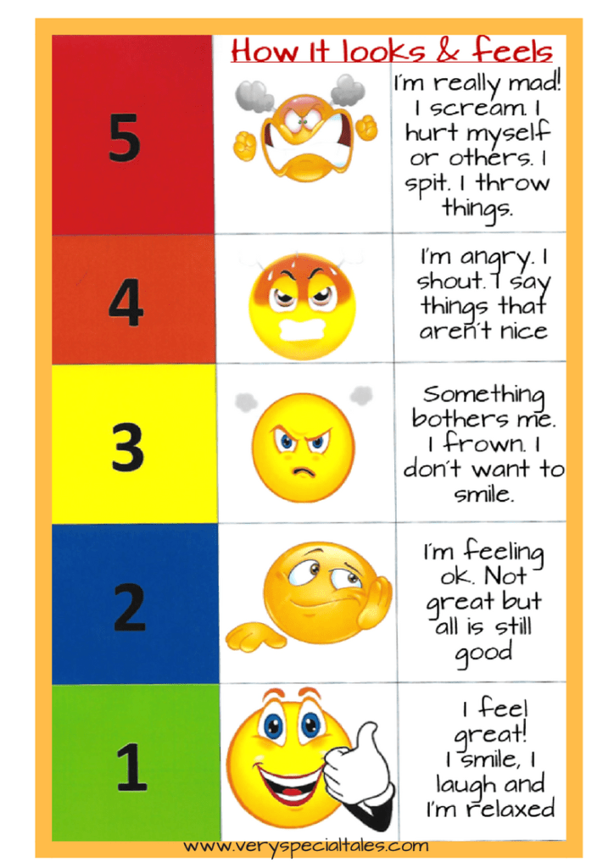
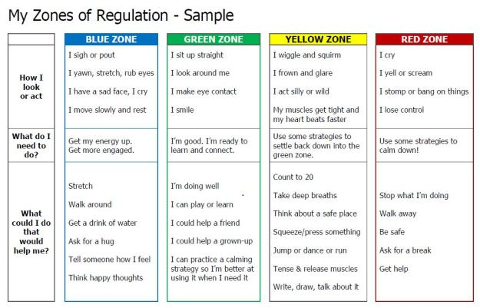

Common Questions on the Zones of Regulation

Can you be in more than one zone at a time?
Yes. Your child may feel tired (blue zone) because she did not get enough sleep, and anxious (yellow zone) because she is worried about an activity or contest at school. Listing more than one zone reflects a good sense of personal feelings and alertness levels.
Should children be penalised for being in the RED zone?
It’s best for children to experience the natural consequences of being in the RED zone. If a child’s actions/choices hurt someone or destroys property, he needs to repair the relationship and take responsibility for the mess they create. Once the child has calmed down, use the experience as a learning opportunity to process what the child would do differently next time.
Can you look like one zone on the outside and feel like you are in another zone on the inside?
Yes. Many of us “disguise” our zone to match social expectations. We use the expression “put on a happy face” or mask the emotion so other people will have good thoughts about us. Parents often say that their children “lose it” and goes into the RED zone as soon as they get home. This is because children are increasing their awareness of their peers and expectations. They make every effort to keep it together at school to stay in the GREEN zone. Home is when they feel safe to let it all out.

Tips for Practising the Zones of Regulation
- Know yourself and how you react in difficult situations before dealing with your child’s behaviours.
- Know your child’s sensory threshold. We all process sensory information differently and it impacts our reactivity to situations.
- Know your child’s triggers.
- Be consistent in managing your child’s behaviour and use the same language you use at home.
- Empathise with your child and validate what they are feeling.
- Have clear boundaries/routines and always follow through.
- Do not deal with an angry, upset child when you are not yet calm yourself.
- Discuss strategies for the next time when you are in a similar situation.
- Remember to ask your child how their choices made you feel (empathy).
- Praise your child for using strategies. Encourage your child to take a sensory break to help regulate their bodies.

Zones of Regulation
Some parents / professionals have found it helpful to compare the zones of regulation to characters from the movie Inside Out, by creating charts like this. (Note: all images copyright Pixar.)
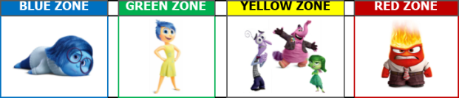
You can teach your child about the Zones. Again, at first, you might label for them the zone you think they might be in. Over time, you ask them to identify their own feelings as they’re experiencing them. Then we work on teaching them the tools they can use in each zone to help them get to (or stay in) the green zone. This vocabulary gives you a common vocabulary for discussing these ideas, which then allows you to work together on problem-solving.

Developmental Stages of Emotional Intelligence
Children go through these stages. They have to first notice and understand an emotion before they can figure out how to manage it.
If we expect a very young child to jump straight to stage 5 and be able to keep themselves calm at all times, they’re simply not going to be successful at that. Like all things, this is a gradual learning process. And like all other skills, sometimes children regress. If your child is up to stage 3 or 4 on a good day, they may go back to step 1 when they’re exhausted, sick, or hungry. Be patient with them as they learn.
Stage 1 – Noticing the symptoms. The first stage is to just get them to notice and talk about the feelings they experience. For very young children, point out to them “it seems like you’re sad” or “I see your eyes are big, and you’re rubbing your hands together – it looks like you’re worried.” As you notice and talk about these things, it can help them notice them too. You can also point out feelings of characters in books or movies, or the people you encounter in daily life.
Stage 2 – Diagnosing feelings. As they get older, ask them to use words to describe their own feelings (or those of others). Once they’re starting to be able to label “the big 4” consistently, then work on describing the intensity of those feelings (maybe using the thermometer image or the zones labels).
Stage 3 – Learning concrete strategies for calming down. Teach them a number of strategies, and have them make lists of what is helpful to them in each zone. For example: if they’re in the blue zone, they might stretch, drink water, or talk to someone. In the yellow zone, they might take deep breaths, count to 10, or write about how they’re feeling. In the red zone, they may move away from the situation that’s upsetting them or ask for help. Practice these skills when they’re calm.
Stage 4 – Being able to implement calming strategies when upset. This is hard work. We can’t expect them to learn overnight! We first work on how to self-soothe the smaller upsets in the yellow zone, and as they get better at that, they might be able to tackle red zone feelings. Until they can, they’ll need support from adults to help with this.
Stage 5 – Understanding what triggers big emotions, taking actions to prevent problems, and use self-care strategies to stay calm when hard things happen. Many adults are still learning this step! But we can teach our big kids, tweens, and teens to be more aware of what situations are often challenging for them and thinking of ways to make those more manageable.
