

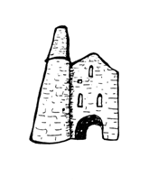St Day and Carharrack Community School

22 Club

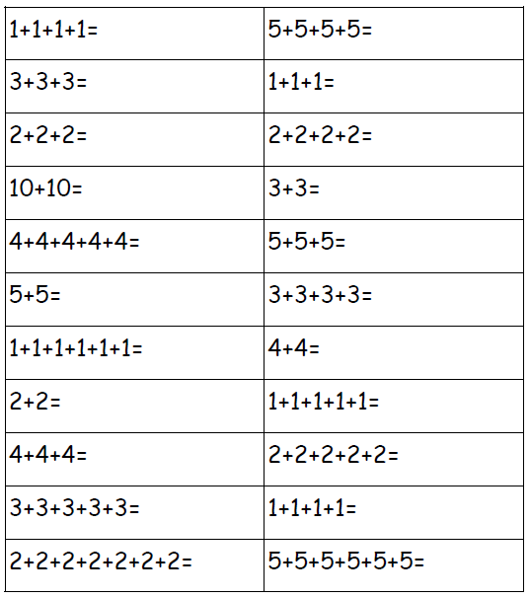Name:___________________ Date:________