Strategies to help your child learn their spellings.
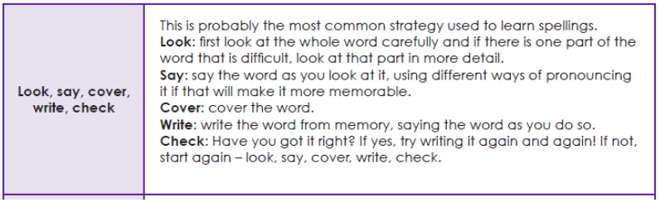 | 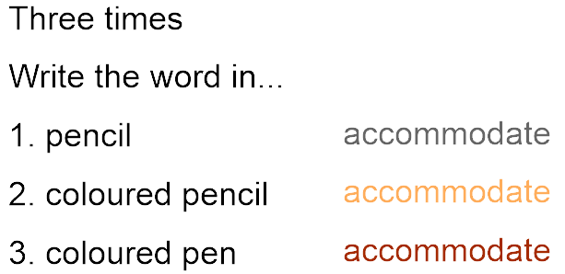
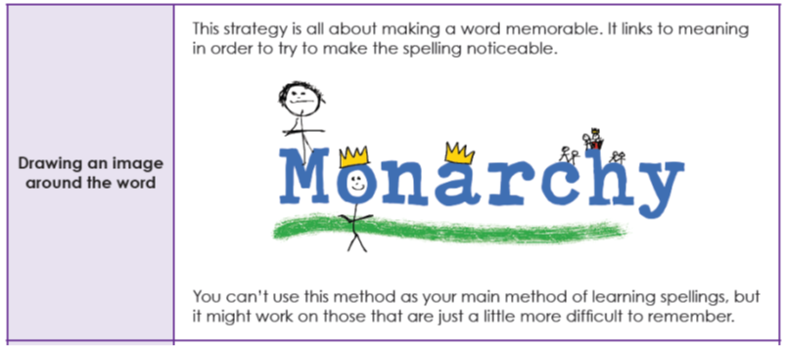 | 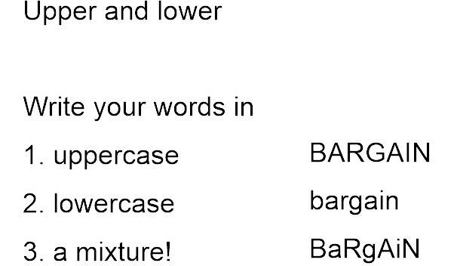
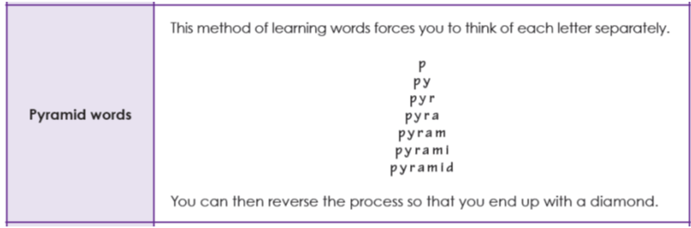 | 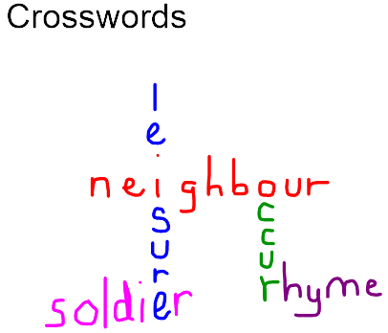
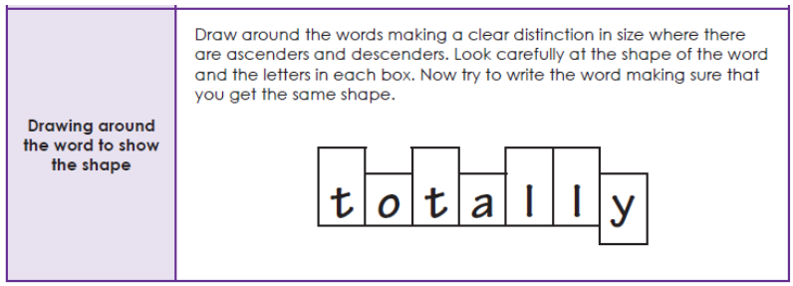 | Words within words  1. Write the word terrible  2. Write two or more words made from the letters  terrible --> bit, tribe, let
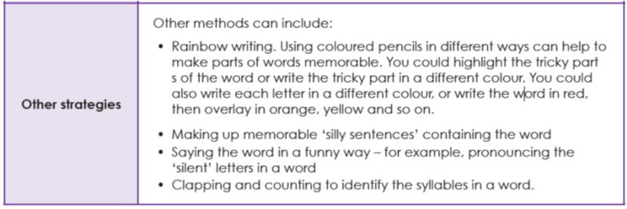 | Words without vowels  1. Write all your words with lines instead of vowels  d_f_n_t_ definite  2. Go back and fill in all the vowels  definite
Fancy words  1. Write your word restaurant  2. Write it in fancy letters restaurant  3. Write it in fancy letters restaurant  again | Backwards words  Write the words forwards and then backwards  e.g. category yrogetac

accident | century | experiment | interest | particular | remember
accidentally | certain | extreme | island | peculiar | sentence
actual | circle | famous | knowledge | perhaps | separate
actually | complete | favourite | learn | popular | special
address | consider | February | length | position | straight
answer | continue | forward(s) | library | possess | strange
appear | decide | fruit | material | possession | strength
arrive | describe | grammar | medicine | possible | suppose
believe | different | group | mention | potatoes | surprise
bicycle | difficult | guard | minute | pressure | therefore
breath | disappear | guide | natural | probably | though
breathe | early | heard | naughty | promise | (although)
build | earth | heart | notice | purpose | thought
busy | eight | height | occasion | quarter | through
business | eighth | history | occasionally | question | various
calendar | enough | imagine | often | recent | weight
caught | exercise | increase | opposite | regular | woman
centre | experience | important | ordinary | reign | women
Year 3 and 4 Statutory Spelling Word List
These are the words that the National Curriculum expects all year 3 and 4 children to say, read and write – spelling accurately.

