Step-by-step guide to completing and submitting work on Google Classroom
- Log in to your Google Classroom account.

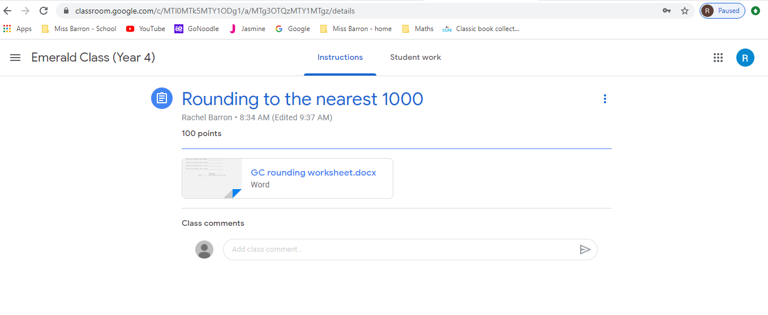
- Select the assignment you wish to work on and open the document attached.

- Once the document is open, click ‘open with Google Docs’ at the top of the page. This will open an editable version of the document for you to work on.
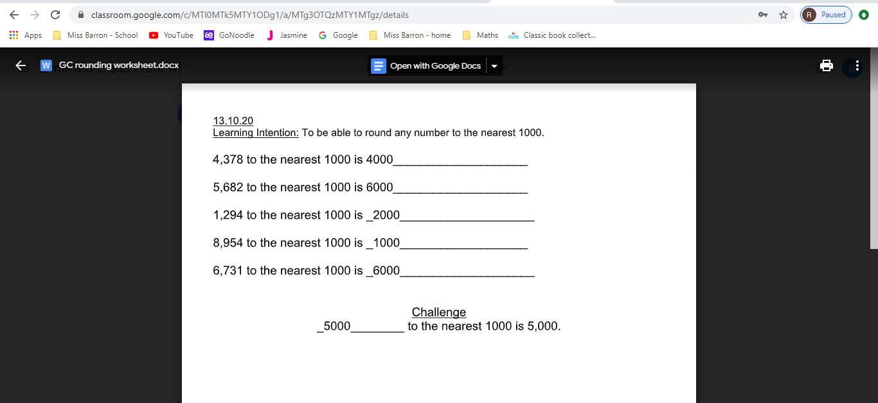

- Once you have finished the work, go to ‘file’ and from the drop down menu select ‘make a copy’.
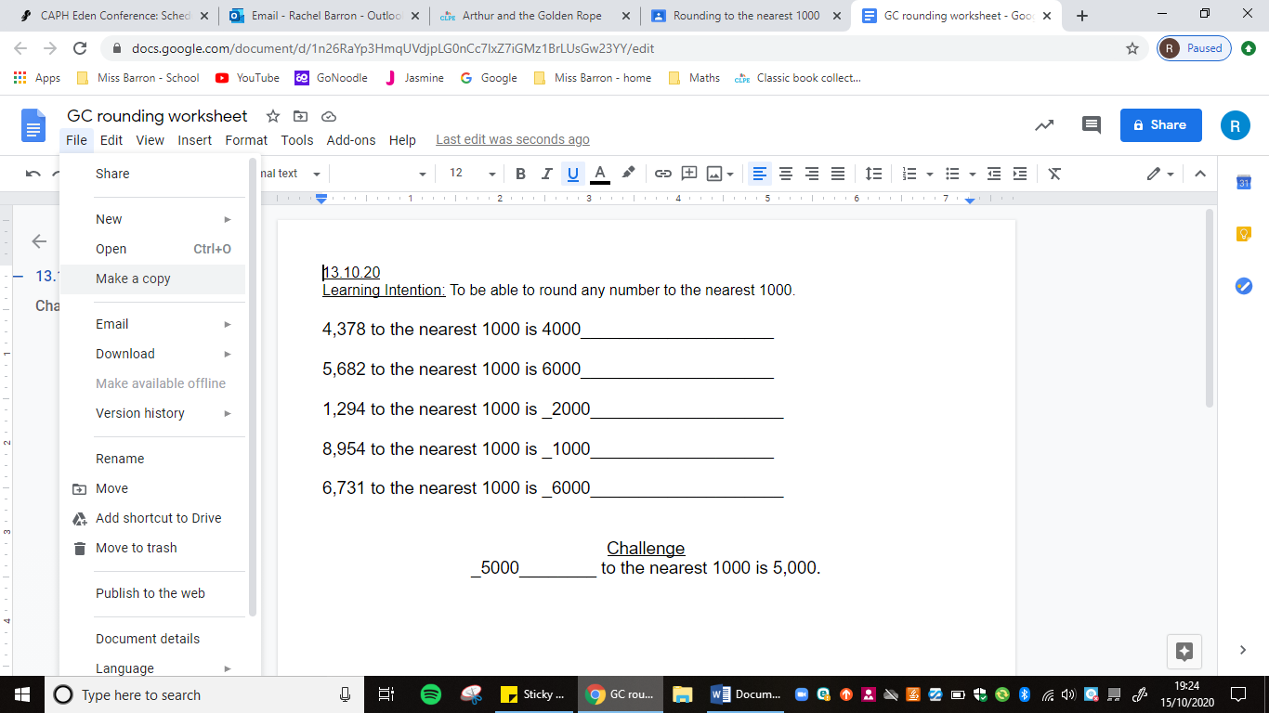

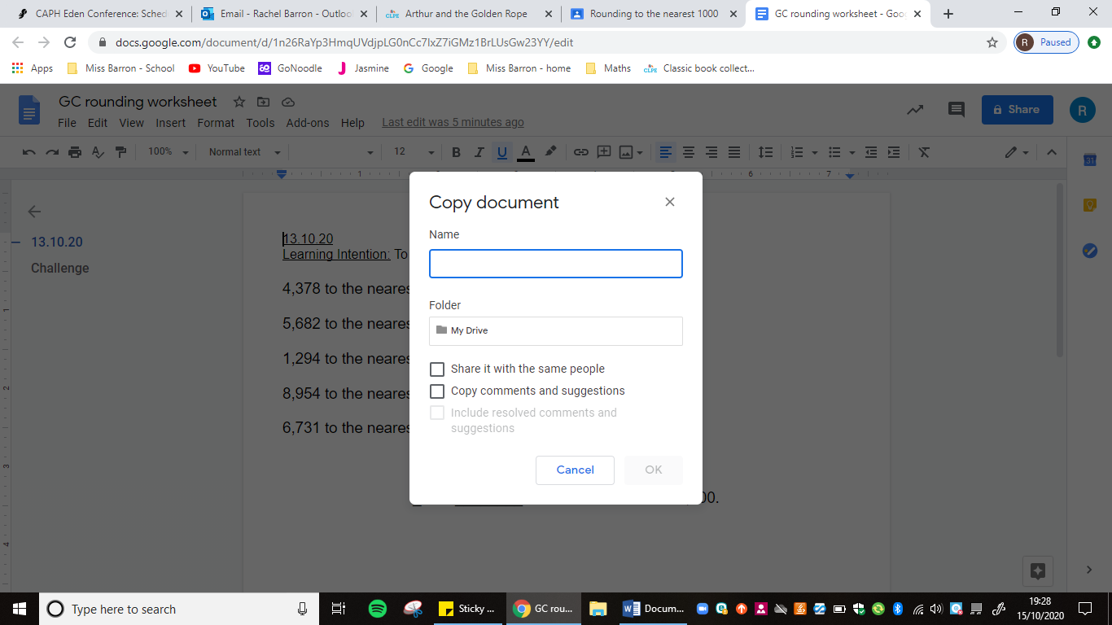
- In the highlighted box that will appear, rename your edited document then click ‘OK’. Your document has now been saved.

- You can now close the editing document page, and return to the Google Classroom assignment page.

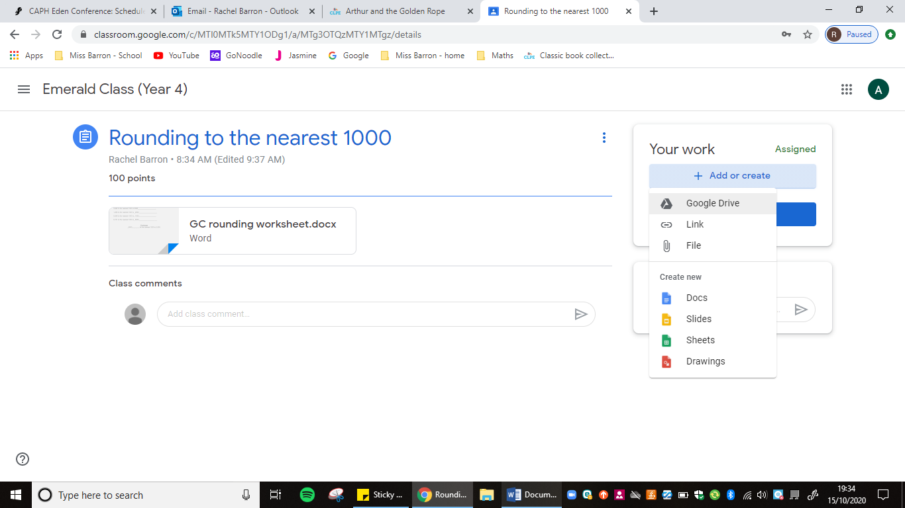
- Click on the ‘+ add or create’ button in the top right of the page and select ‘Google Drive’ because this is where your document has been saved.

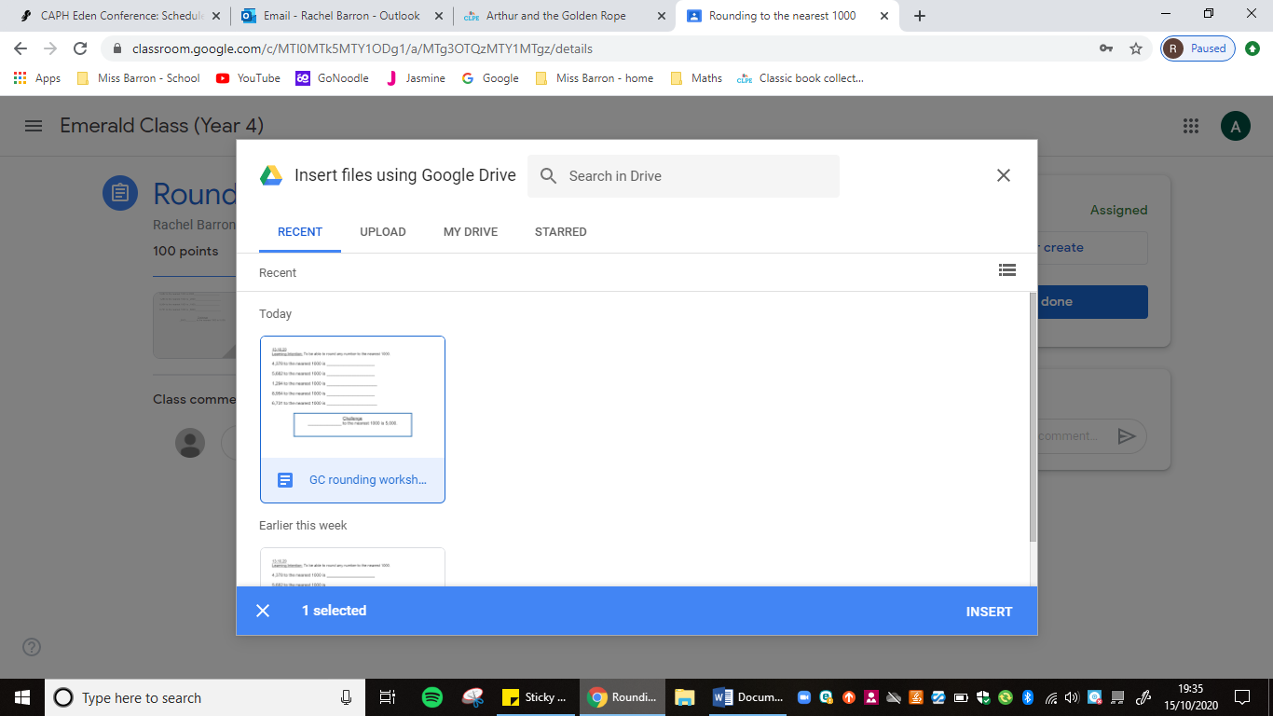
- Select the required document from the list and click ‘insert’ down in the bottom right.

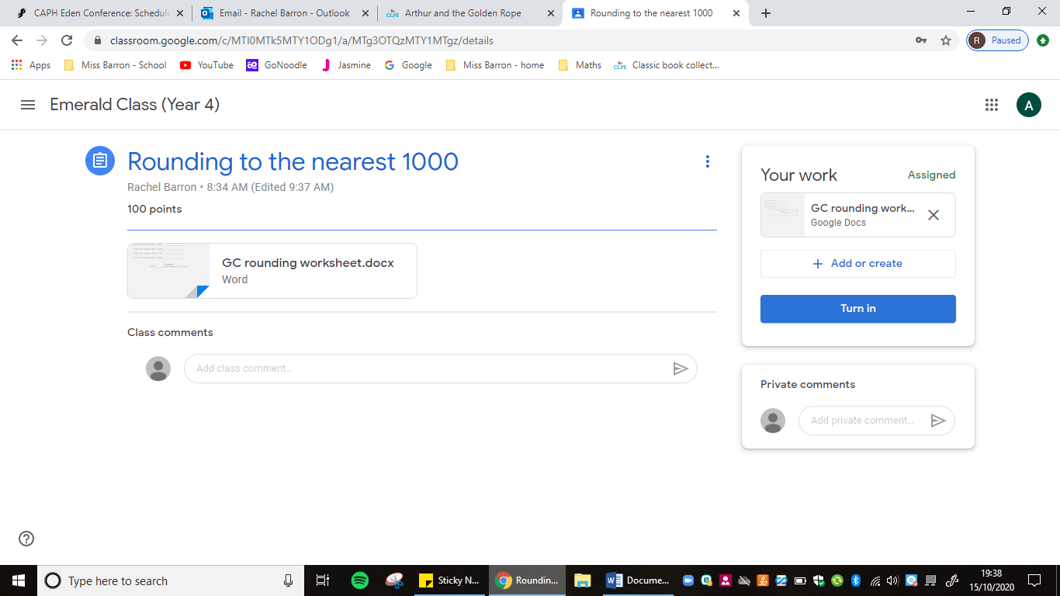
- Your document will now be uploaded and to finish the process you have to click on the ‘turn in’ button.

- Your completed work has now been submitted and the class teacher will be able to see the work from their teacher account.

