Returning to school: 8 tips to help your child after lockdown
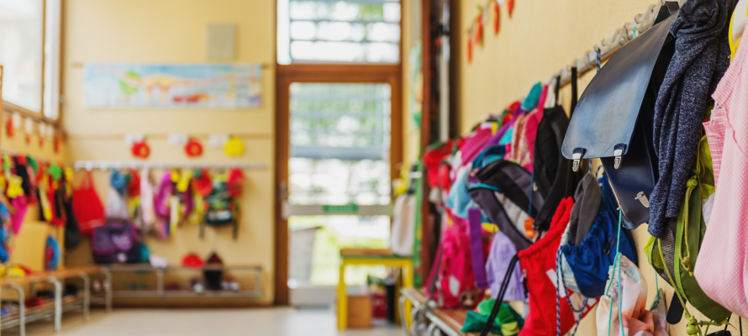
Image: annanahabed/stock.adobe.com
From this week, children and young people in England will begin returning to school – but not school as they know it.
As quickly as they were thrust into the isolation of lockdown, suddenly pupils will be dealing with new school rules, routines, classrooms, classmates, teachers and, in some cases, even new schools.
For many, these changes will inevitably create anxiety, especially given the ongoing threat of COVID-19 and new school social distancing and hygiene measures. More so again, if they’re leaving other family members ‘safe’ at home.
To make their transition easier, here are eight things to consider if your child is returning – or preparing to return – to the classroom.

1. Talk to them about how they feel
It is important to encourage your child to discuss their feelings about returning to school. This may require a difficult conversation about the pandemic, especially in light of the school’s safety measures.
If they feel anxious or worried, help them understand this is perfectly normal, and that you and their teachers are there to support them. Although difficult, try not to share any anxiety you may have with them.
Also bear in mind your child may be returning to a pre-existing issue from before lockdown – for example, a bullying or relationship issue, or difficulty with school work or staff – or they may be preparing to leave school in Year 6.
Try to give them a non-judgemental and supportive place to share any anxiety. Younger children, in particular, may not always have the words to express their feelings, so try to find a way of bringing up the conversation without putting pressure on them – for instance when you’re playing with them, or going for a walk. This can help them to open up naturally and identify what they’re anxious about. If you are concerned about their mental wellbeing, extra support is available.

2. Pack right, pack light
If your child is eligible to return, your school will have been in touch to let you know what they should and (more likely) shouldn’t bring in – such as stationary, bags, PE kits, bottles and lunch.
Make sure you have checked what they need, in order to make your child’s day easier. It is important to be aware that neither children nor staff are recommended to attend school in PPE (ie, facemasks) as government guidance has outlined this potentially adds to the risk of infection, rather than reducing it.

3. Make sure they understand the rules
Your school will have also been in touch to explain the various new procedures in place during the phased reopening – such as the 2-metre rule. If you haven’t received this information or are unsure what the rules are, you should contact the school office.
It will be important for your child to understand social distancing and hygiene rules and, importantly, why they are in place.
This potentially includes being distanced from friends or siblings throughout their school day, which may be hard to understand but important to accept.
Make sure you read all school communications with your child and make sure they are prepared, so it is not a shock when they enter the school gates.

4. And make sure you know the rules too
It will be important for schools – and your child – that you know where and when to drop them off and pick them up, as well as what parts of the school you can access.
Your child will be eagerly expecting you at collection time, so make sure you, or whoever is collecting them, are there for them, in the right place at the right time.

5. End of day emotions – don’t push them
For many children, a school day can require a lot of self-regulation or compressed behaviour, which can lead to tired and emotional outbursts later on in the day. Given the length of the lockdown and the new school safety rules in place, these emotions may be hard to cope with when they return.
It is a good idea to keep this in mind, and allow for some ‘letting off steam’. Your instinct may be to ask about their day, but be aware that your child may prefer to simply unwind.

6. But stay informed
Given the social distancing rules, classes (or ‘bubbles’) of 15 mixed-age children may be asked to do different school work than they are used to. This may create fresh challenges for your child, from working with new classmates and teachers, to coping with their work. Try to stay informed about how they are getting on – but if you are concerned, contact the school office about speaking to the class teacher.

7. Be mindful, be fair
If your child is going back to school when other family members – including siblings – are staying home in lockdown, life may feel a little unfair (and why not?).
While you may be up early to get them fed, dressed and ready for the school day, it is worth thinking about whether the rest of the family should be up and about too.
Also be mindful of what others are doing at home during the school day. Your child may not appreciate it if they come home to find out a sibling has been meeting friends in a park all day, while they have been sitting in a classroom.

8. And get some rest...
Your family may have been getting used to some rather unusual hours during lockdown, given the restrictions on their lifestyle over the past 10 weeks.
Make sure they are getting a good night’s sleep for their return to school. It might mean introducing some earlier bedtimes than they have had recently, but a good night’s rest will help them cope with the return to school and the new routines they will be adapting to.

https://parentinfo.org/article/returning-to-school-8-tips-to-help-your-child-after-lockdown

