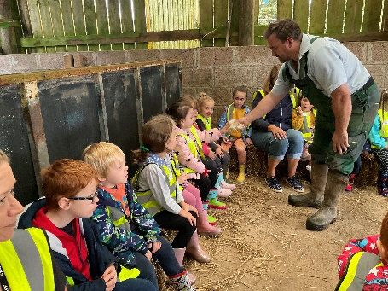
16TH October 2023

OPAL CLASS

Dear Opal Families
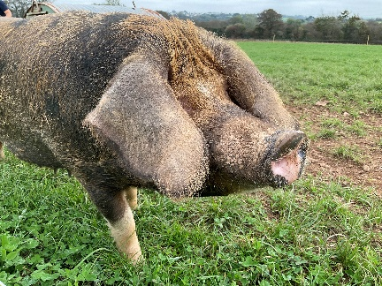
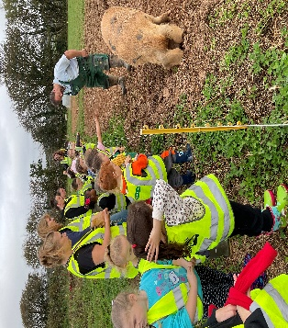
Our farm visit was a HUGE success! The Edmonds put on an amazing day. Throughout the day the children spent time with the animals, including pigs, sheep, chickens and cows. All day the children recited "Were going on a farm hunt" and they really experienced ‘squelchy mud and swishy swashy grass’. After a busy morning the children enjoyed a fantastic trailer tractor ride to explore more of the farmyard grounds. This week we will make story maps about our experience to the farm based on the story ‘We’re going on a Bear Hunt’. For mathematics we will focus on making repeating patterns. I can’t believe we have completed the 1st Autumn Half term already but I think the children are definitely ready for a holiday. They have settled in so well and are truly a magnificent class. Thank you to all parents for attending Parent Partnership meetings it was lovely to hear how the children are enjoying school.
Have a lovely Half Term holiday everyone and remember we return to school on the Monday 30th October for some spooky fun!
This week’s key reminders:
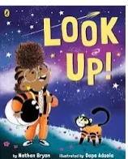
- PE - Friday (Children come to school already dressed in their PE kits ready for the morning thank you)
- Half Term Holiday – Monday 23rd October - Friday 27th October
- Return to school – Monday 30th October

Black History Month
This week we will read ‘Look Up’ We are celebrating Black History month in school which links to article 2 ‘No Discrimination’ from the Children’s Convention of Rights, as we are a Rights Respecting School. Link below to watch online.
https://www.google.com/search?q=look+up+book&rlz=1C1GCEJ_enGB1038GB1039&oq=look+up+book&gs_lcrp=EgZjaHJvbWUqCggAEAAY4wIYgAQyCggAEAAY4wIYgAQyBwgBEC4YgAQyBwgCEAAYgAQyBwgDEAAYgAQyBwgEEAAYgAQyBwgFEAAYgAQyBwgGEAAYgAQyBwgHEAAYgAQyBwgIEAAYgAQyBwgJEAAYgATSAQkzNzEyajBqMTWoAgCwAgA&sourceid=chrome&ie=UTF-8&safe=active&surl=1#fpstate=ive&vld=cid:4f632e4c,vid:UZrr-KTpoCU,st:0
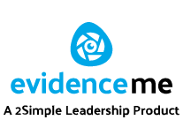

Welcome to ‘Evidence Me’ programme. This programme is used in Opal class in order to share the learning between parents and the EYFS team in school. This is an up to date system used to collate observations in our EYFS classroom in supporting the next steps in learning. ‘Evidence Me’ allows you to share your learning at home with teachers in school also. Please read the attached letter in order to find out how.

High Frequency Words
Please note we are going to start learning our common exception words (high frequency words) in school. These are words that cannot be easily blended e.g. sounded out like the word c-a-t phonetically. These words pop up everywhere and need to be learnt by learning them by sight. There is no expectation of test at the end of the week and I really stress that parents support their children at home by making the learning fun and playful.
New words this week includes: you
The link below has lots of fantastic fun ideas you can pinch at home to help your children learn these words at home.
https://phonicsfamilycom.wordpress.com/ Phonics Family
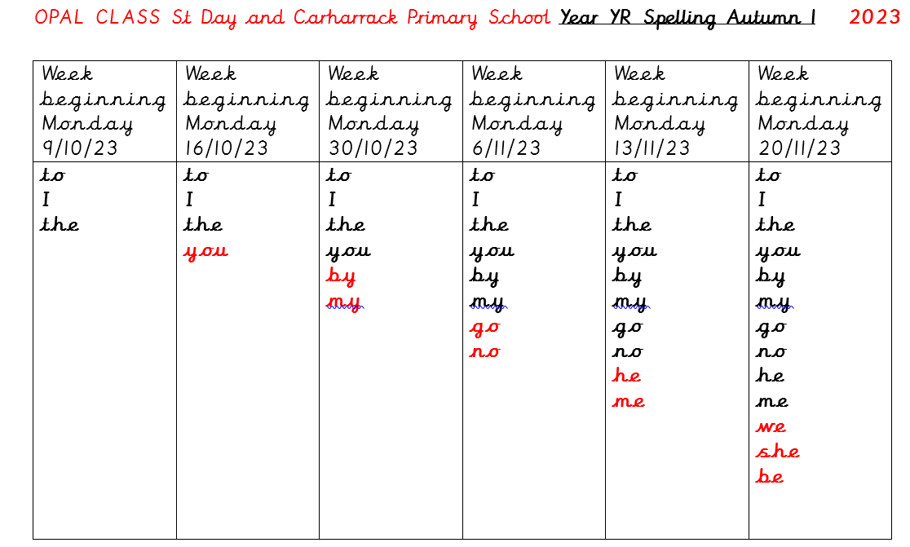

Read Write Inc
The letters we aim to learn this week include: e l h
Watch these great film clips of Fred and Elly learning RWInc. Go to the following links on the Ruth Miskin Read Write Inc site online:
For the sound e: https://schools.ruthmiskin.com/training/view/3tbFMAGX/Xjk6FllH
For the sound l: https://schools.ruthmiskin.com/training/view/SQyj4LXi/lm55c0nR
For the sound h: https://schools.ruthmiskin.com/training/view/XEuuBvRH/pV1W2Kfm
For the sound u: https://schools.ruthmiskin.com/training/view/3RpaB9wk/wNt2P1wB
For the sound b: https://schools.ruthmiskin.com/training/view/WSP8excs/ZUySEZRz
For the sound f: https://schools.ruthmiskin.com/training/view/t7I8Aeck/GsxVu5gs
For the sound o: https://schools.ruthmiskin.com/training/view/laUL8MuN/SEv7Kob2
For the sound c: https://schools.ruthmiskin.com/training/view/qmm6nC67/o4y9lARi
For the sound k: https://schools.ruthmiskin.com/training/view/9eaDo5E9/4uHAN71M

Any queries any time please ask!!
Viv Horne
Opal Class Teacher

