St Day & Carharrack Community School
Acceptable Computer Use Agreement for Children (updated 2018)

All children use computer facilities including Internet access as an essential part of learning. We expect all children to be safe and responsible when using any IT. Please read and discuss these eSafety rules with your child and return the slip to give your consent.
Computers are a fantastic resource and offer great potential to support the curriculum. Internet access at school is available to the children through NCI which is a safe environment, protected by both a firewall and filtered content.
We teach the children how to be responsible and safe with the resources and on the internet. We follow the rules of ‘Be SMART on the internet’ and age appropriate resources for KS 1 which can be found below and at www.childnet.com. This site contains lots of useful information for parents including how to support younger children.

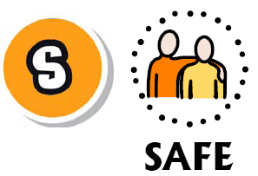
Keep safe by being careful not to give out personal information – such as your name, email, phone number, home address, or school name – to people who you don’t trust online.

Meeting someone you have only been in touch with online can be dangerous. Only do so with your parents’ or carers’ permission and even then only when they can be present.

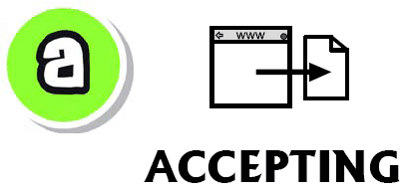
Accepting emails, IM messages, or opening files, pITures or texts from people you don’t know or trust can lead to problems – they may contain viruses or nasty messages!

Someone online may be lying about who they are, and information you find on the internet may not be reliable.

Tell your parent, carer or a trusted adult if someone or something makes you feel uncomfortable or worried. You can report online abuse to the police at: www.thinkuknow.co.uk.

St Day & Carharrack Community School
Acceptable Computer Use Agreement (updated 2018)

eSafety Rules

- I will follow the SMART rules and only use IT in school for school purposes.
- I will only use my class e-mail address or my own school e-mail address when e-mailing.
- I will not tell other people my IT passwords.
- I will only open/delete my own files.
- I will make sure that all IT contact with other children and adults is responsible, polite and sensible.
- I will not deliberately look for, save or send anything that could be unpleasant. If I accidentally find anything like this I will tell my teacher immediately.
- I will not give out my own details such as my name, phone number or home address. I will not arrange to meet someone unless this is part of a school project approved by my teacher and a responsible adult comes with me.
- I will be responsible for my behaviour when using IT because I know that these rules are to keep me safe.
- I will support the school approach to online safety and not deliberately upload or add any images, video, sounds or text that could upset any member of the school community
- I know that my use of IT can be checked and that my parent will be contacted if a member of school staff is concerned about my eSafety.

✂
Parent’s Consent for Internet Access
September 2018

Child’s Name: ……………………………..

We have discussed the school e-safety rules and I give permission for my child to access the Internet. I understand that the school will take all reasonable precautions to ensure that children cannot access inappropriate materials but I appreciate that this is a difficult task. My child agrees to follow the e-Safety rules and to support the safe use of IT at St Day & Carharrack Community School.

Parent Signature …….………………….………………………….

Class …………………………………. Date ………………………………

