St Day and Carharrack School Newsletter

23rd April 2019 - Issue 14

Headteacher: Susannah Storey

Telephone: 01209 820456

email: secretary@st-day.cornwall.sch.uk

WELCOME BACK EVERYONE! We hope you have all had a restful, peaceful and happy break. The summer term is always busy and we are excited about all the new learning topics and events taking place. Your child's curriculum overview will be with you by the end of this week and posted on the website. The whole school will be busy revisiting and discovering new Geography skills, knowledge and understanding through an exciting class topic.

TREE PLANTING
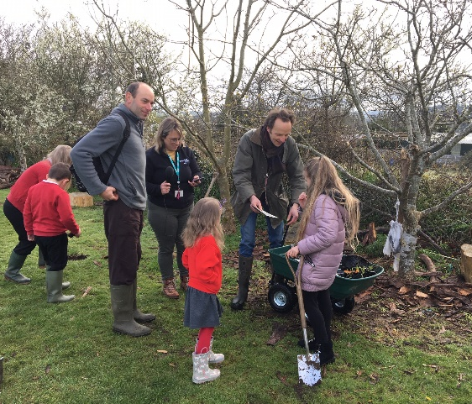
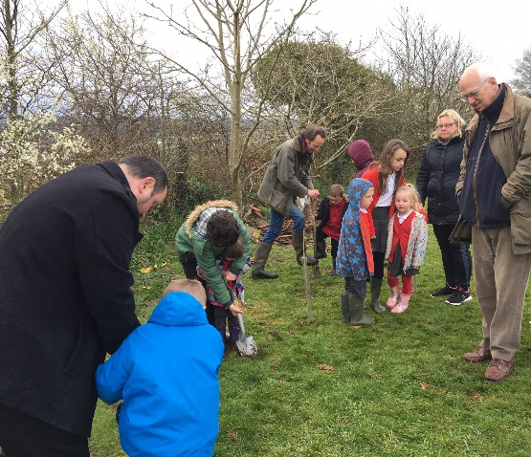

We finished the spring term digging and planting 200 trees donated by The Woodland Trust! Huge thanks to Mr Baring (forest school teacher) and Mr Newman (parent volunteer) for supporting every child in the school to plant their very own tree! We learned in mixed year groups across the school and as Jayden reported to Radio Cornwall, ‘It is fun to be outside and not cooped up inside. It is important to all learn together and have a good time. I enjoy being with the younger children as I can teach them’. Our youngest children can care and watch their tree grow over the years and we hope our older children will always feel a connection to bring them back to our school in the future. In outdoor learning, we continue to develop a range of skills including carpentry – making raised beds and planters. We hope to encourage more of our children to enjoy being outside this term - to help boost their confidence and well-being.

THE GREAT ST DAY AND CARHARRACK BAKE OFF RAISED £418!
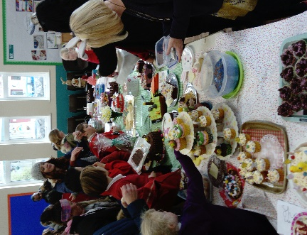
This was a magnificent display of cakes and amazing baking talent – thank you to everyone for taking part – making, buying and eating cake! The top cakes- judged by our very own professional cake-maker parent: - Briony Togneri belonged to Ashleigh, Sam and Freddie – congratulations! Special thanks to Jess Emery and Lynsey Hocking for taking the initiative and putting together the fabulous raffle prizes and well done to the top three winners: Kianna, India and Naomie – we hope you enjoyed your prizes! We hope to hold a summer or Christmas Fayre and would like to welcome parents to come to the office and sign up to help – we can’t do it without you!

RAFFLE PRIZES WINNING CAKES
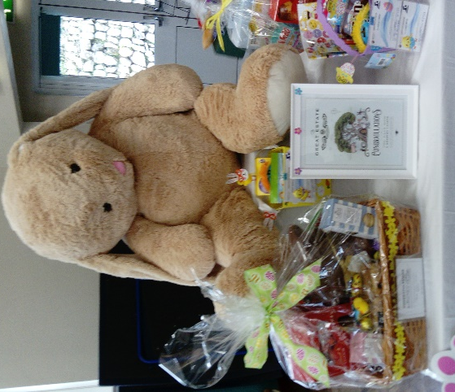
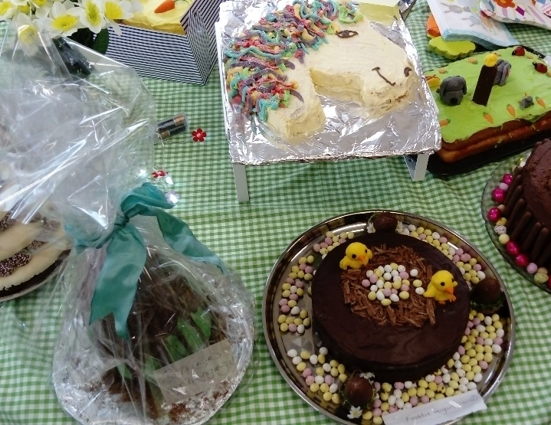

CELEBRATING OUR MUSICIANS
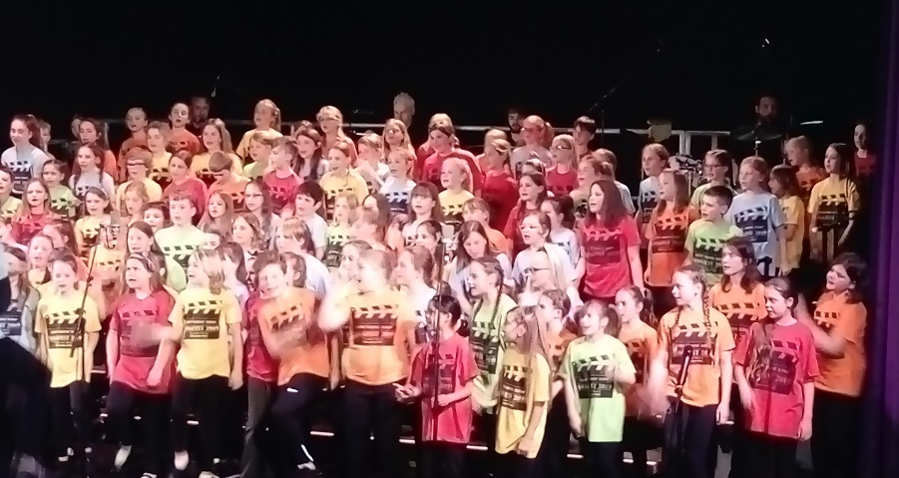
We have had another action packed musical term with Mrs Vanstone leading many groups and culminating in some fabulous performances. Many thanks to Mrs Vanstone for all her inspiration and volunteering so much of her time. Congratulations to our children for their determination and courage to perform and many thanks to you our parents for supporting all the events including the Cornet Concert and end of term performances. Our school choir have been incredibly active in and out of school and performed on stage at Redruth Theatre for SONGFEST and at Church with the Daylight Choir. They just got better and better each time! A super well done everyone!
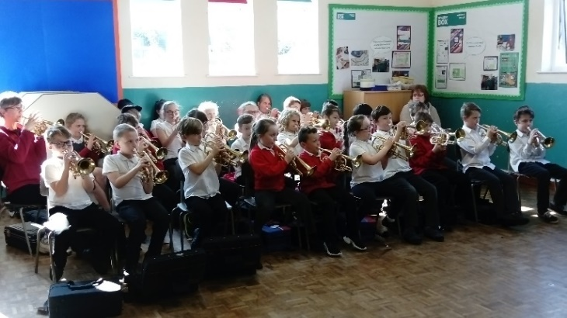

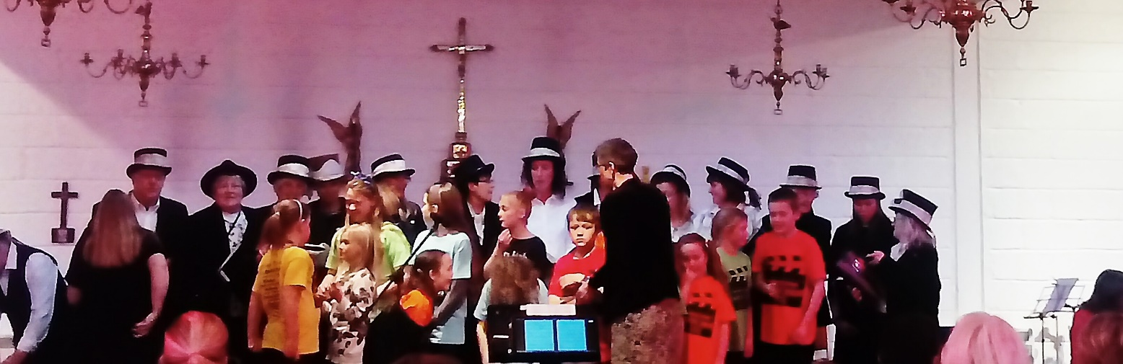
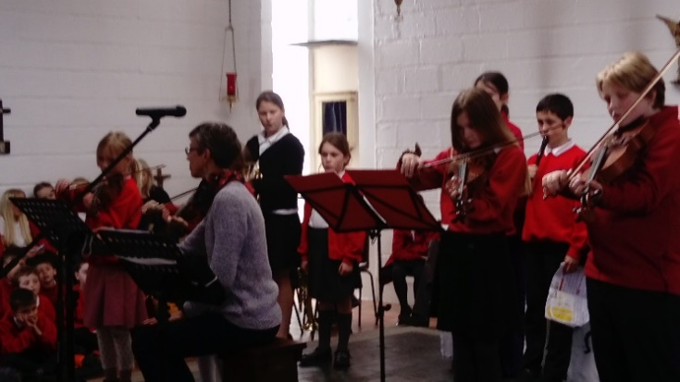

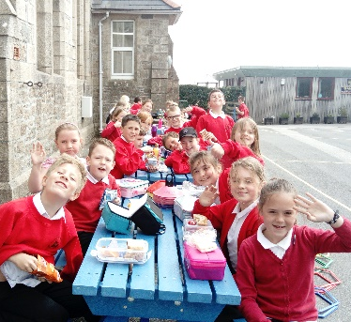
FUNDRAISING
Huge thanks to all our parents for supporting us at Christmas -We have invested the money raised at Christmas in our new recycled plastic benches, which will hopefully last for many many years! The remainder of the money has been used to buy much-needed new atlases for the whole school. This will greatly support our Geography focus for this term.

SAFEGUARDING, HEALTH AND SAFETY – OUTSIDE LEARNING SPACES
Please note, that the school has been actively pursuing tighter school security measures around the site perimeter since this time last year. The Local Authority have gone to tender for the essential extensive grounds work, with the process nearing completion. The school expects to hear in the near future, who has been selected and when the work will begin. In the meantime, please supervise your children closely out of school hours – children should not be in the wooded area where there are a number of drops straight to the road. Den building is a school-hours supervised activity only. The school cannot be held responsible for any incidents out of school hours- before 8.55am or after 3.10pm - when your children are in your care. During the school day, children are supervised in the woodland – this is a learning area extension of our school, which should only be accessed during the school day and under supervision. Thank you for your support with this.

YEAR 5 MAYA MARKET – in the last week of term, Sapphire Class celebrated their spring term learning with a Maya Market. Families of children in Sapphire Class were welcomed to enjoy food, art, design and writing which the children had worked extremely hard on creating inspired by our topic work. We would like to thank you, families, as your kind donations at the market helped us to raise £67, which we will put towards reducing the cost of our summer term trip. Brilliant effort, Sapphire Class! Please see our photos on the website Gallery.

TEACHING ASSISTANT APPOINTMENT - we are pleased to announce that we have appointed a new member to the team – Helen Bolt will be joining us from the start of the summer term as a teaching assistant. We welcome Helen Bolt to our school and hope she will be very happy here.

ATTENDANCE – LATE MARKS AND PENALTY NOTICES
Our expectation is for every child to be punctual for the start of the school day as this supports everyone in our school and most importantly your child. Thank you to the vast majority of our families for supporting us to have a smooth start to the day. In response to parent feedback during Education Welfare meetings and for absolute clarity regarding procedures, the school doors will be closed promptly at 8.55am. If your child is later than 8.55am, they will have to enter through the front door office – this means your child is late and their late time will be recorded on their individual attendance record. Please be aware that a build-up of ten or more lates after the register closes will result in unauthorised absences and lead to Educational Welfare involvement including a first warning penalty notice being issued. KS1 parents are kindly asked to arrive at 8.45am if you wish to settle your child in class. We are requesting all parents to leave the school building promptly through the KS1 or KS2 entrance by 8.55am rather than walking through the school building unsupervised. This is a safeguarding and safety request. We will be reviewing parent drop off to ensure safeguarding procedures are efficient and to enable all of our children to have the best possible start to the day.

REMINDERS
SUNSHINE AND SHOWERS- Please can we ask for sun cream to be applied before school and for both sunhats and coats to be in school daily due to the changeable weather. Thank you.
READING BOOKS AND SIGNED READING RECORDS – To be in school daily please. This is vital to support your child progress in all areas of the curriculum. Reading with and to your child daily is not only enjoyable – it is the single most important thing that can have a major impact on your child’s development.

WATER BOTTLES AND PE KITS – Please return your PE kits to school and remember to bring your water bottle in each day with fresh water in. Without a PE kit, your child may miss additional opportunities to be involved in sport and physical activity; these pop up all the time in school so please help your child to ensure they are fully equipped every day. If a PE kit goes home following a club, please return it the next day. Thank you.

DINNER MENU CHANGES – Please see the new menu on our school website in addition to a paper copy sent to every family.

CLUBS START 29 April – Please return your slip to the office as soon as possible.
We also have a new club starting: Parent and Child Drama workshop and Well-Being session – Wednesdays 3.15pm – 5pm - run by Jason Squibb and Abbey Myners. This is a creative and fun family drama workshop with a well-being session included - mindfulness, breath, yoga and sound. It is being funded by FEAST with an additional £1 per person payable on the day.

SAFEGUARDING YOUR CHILDREN’S FUTURES -We are launching our very own KINDNESS, RESPECT and ANTI-BULLYING RAISING AWARENESS WEEK, officially starting on April 29th to ensure that every member of staff and child in our school feels happy and safe every day. You will receive a detailed letter this week including reference to the updated policies and procedures on our website.

Additional letters on the website and being sent out this week: SAFEGUARDING YOUR CHILDREN’S FUTURES, Class Curriculum Overview, Clubs Letter and Dinner Menu

CONGRATULATIONS TO OUR GOLDEN STARS
Opal class Lacey for making an extra effort in learning especially in literacy.
Rusty for showing great maturity in all of his work and following our Golden Rules.
Jade Class Isabel for having resilience and being independent.
Wes for amazing ability to make others smile!
Amber Class Leo for being hard working and a good class role model.
Ailla for being supportive and caring towards others.
Topaz Class Jacob for a superb effort across all subjects and always joining in.
Caja for trying really hard to catch up with missed learning – extra learning at home.
Emerald Class Lewis for enthusiasm, imagination and always keeping our Golden Rules.
Rhys for being motivated and focused.
Sapphire Class Piran for consistent effort across all learning.
Felicity for continuing to meet all expectations regardless of her injury. Well done, Felicity! Great resilience.
Turquoise Class Anya for having great confidence in Maths.
Jayden for being a great role model and attitude to learning.

Thank you – The St Day and Carharrack Team

