

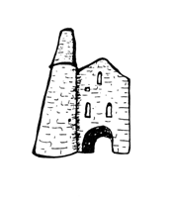**St Day and Carharrack Community School.**

55 Club

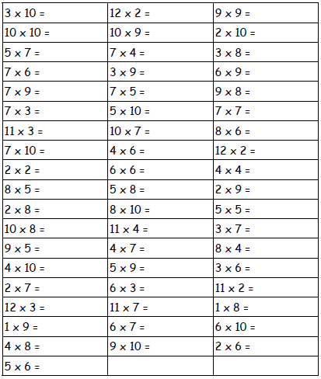Name:___________________ Date:________