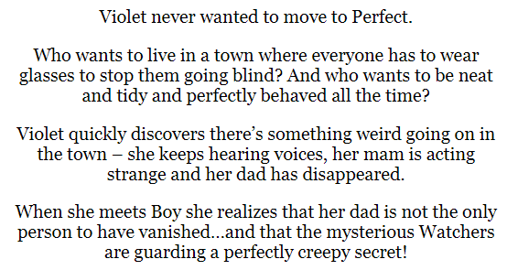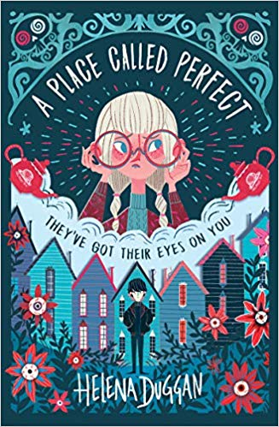

**Day one**

1. Look at the front cover: make a prediction about the story by using the title and the images on the front of the book.

___________________________________________________________________________________________________________________________________________________________________________________________________________________________________________________

1. Read the blurb. Why do you think everyone goes blind in Perfect?

**___________________________________**

1. Do you think that the place called Perfect is perfect? Explain your answer.

________________________________________________________________________________________________________________________________________________________________________________________________________________________________________________________________________________________________________________________________________________________________________

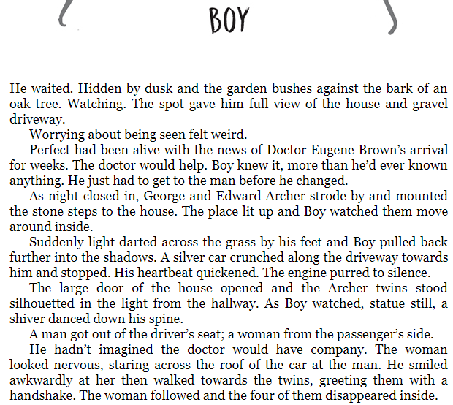

Read the extract of chapter one, **‘Boy’.**

4) Clarify what the phrase, ‘Perfect had been alive with the news…’ means.

__________________________________________________________________________________________________________________________)

5) What do you think the Doctor will help with?

__________________________________________________________________________________________________________________________ Find a word in the text which is similar in meaning to a risky manoeuvre.

_____________________

7) Why do you think the girl could be frightened?

__________________________________________________________________________________________________________________________

**Grammar focus**

**8) Find an example of an adverbial phrase in the text. _______________________________________________**

**9) Find an adverb in the text. __________________**

**10) Find an example of parenthesis in the text.**

**_______________________________________________________**

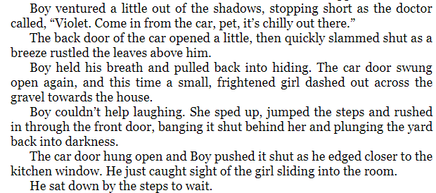

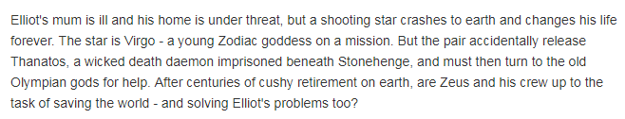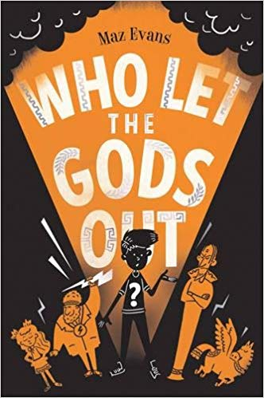

1) Look at the front cover: make a prediction about the story by using the title and the images on the front of the book.

__________________________________________________________________________________________________________________________________________________________________________________________________________________________________________

2) Read the blurb. Clarify what a ***cushy retirement*** is.

**___________________________________**

3) What do you think Elliot’s problems are?

______________________________________________________________________________________________________________________________________________________________________________________________________________________________________________________________________________________________________________________________________________________________

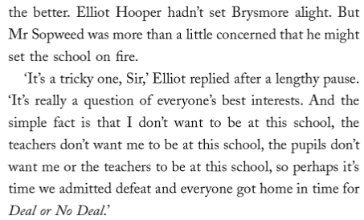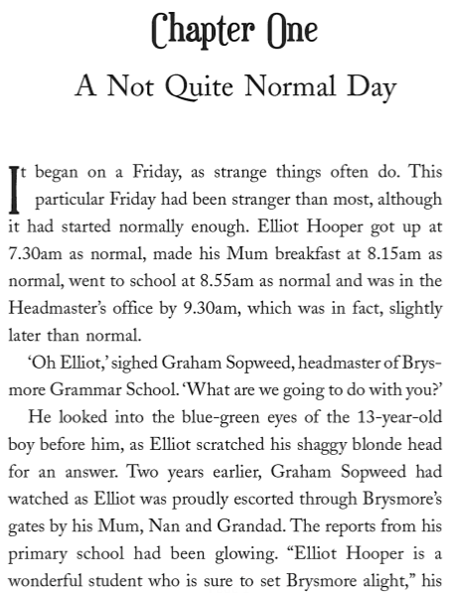

Read the extract of chapter one, **‘A Not Quite Normal Day.’**

4) Why has the author repeated the word ‘normal’ in the first paragraph?

______________________________________________________________________________

5) Find a word that is a synonym for guided.

______________________________

6) What is Mr Sopweed worried that Elliot might do to the school?

________________________________________________________________________________

7) Find evidence that Elliot doesn’t want to stay at school.

_________________________________________________________________________________

**Grammar focus**

**8) Find an example of an apostrophe for contraction. ___________________**

**9) Find 3 adjectives from the text. __________________**

**10) Find a hyphenated word in the text. _______________________________**

**_______________________________________________________(1 mark)**

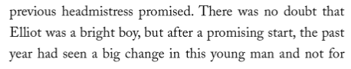

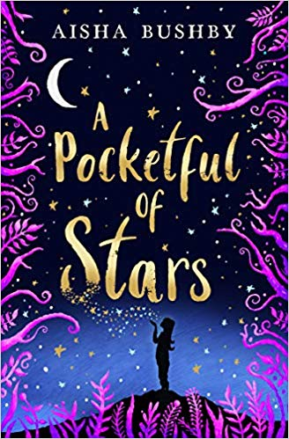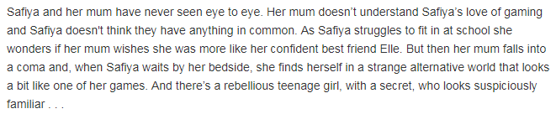

**Day three**

1) Look at the front cover: make a prediction about the story by using the title and the images on the front of the book.

__________________________________________________________________________________________________________________________________________________________________________________________________________________________________________

2) Read the blurb. What does, ‘**had never seen eye to eye’** mean?

**____________________________________________________________________________**

3) What does it mean to **fall in to a coma?**

______________________________________________________________________________

4) What impression do you get of the character Safiya?

_______________________________________________________________________________

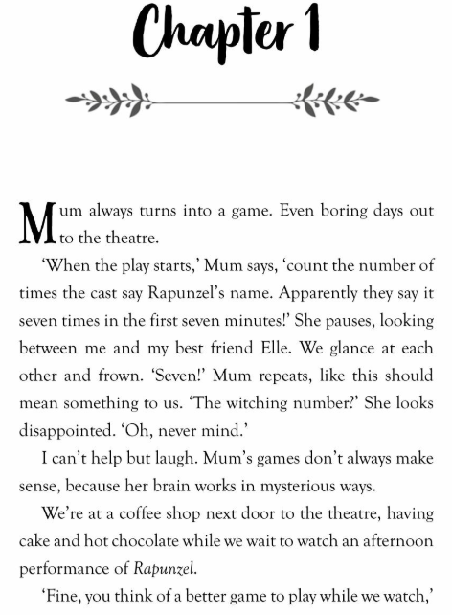

Read the extract of chapter one, **‘Chapter 1.’**

4) What impression do you get of the character, ‘Mum?’

__________________________________________________________________________________________________________________________

5) What does mum think the number 7 means?

__________________________________________________________________________________________________________________________

6) Find the word which means to pull a miserable face.

_____________________

7) Find the synonym for look.

_________________________________

**Grammar focus**

**8) Expand the noun phrase, ‘a coffee shop.’ _______________________________________________**

**9) Find and copy an example of a subordinate clause. _______________________________________________________**

**10) Expand the contraction ‘we’re.’**

**_______________________________________________________**

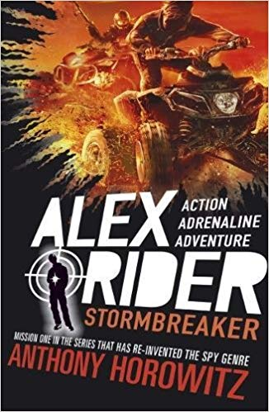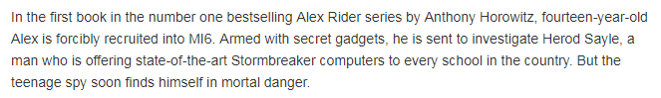

1) Look at the front cover: make a prediction about the story by using the title and the images on the front of the book.

__________________________________________________________________________________________________________________________________________________________________________________________________________________________________________

2) Read the blurb. What does ‘**forcibly recruited’** mean?

**____________________________________________________________________________**

3) What ‘mortal danger’ do you think Alex Ride could be in**?**

______________________________________________________________________________

4) According to the text, what is Alex Rider’s first mission?

_______________________________________________________________________________

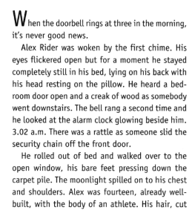

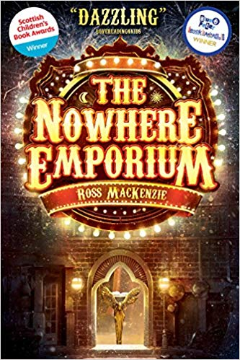

When the mysterious Nowhere Emporium arrives in Glasgow, orphan Daniel Holmes stumbles upon it quite by accident. Before long, the 'shop from nowhere' -- and its owner, Mr Silver -- draw Daniel into a breath-taking world of magic and enchantment. Recruited as Mr Silver's apprentice, Daniel learns the secrets of the Emporium's vast labyrinth of passageways and rooms -- rooms that contain wonders beyond anything Daniel has ever imagined. But when Mr Silver disappears, and a shadow from the past threatens everything, the Emporium and all its wonders begin to crumble. Can Daniel save his home, and his new friends, before the Nowhere Emporium is destroyed forever?

1) Look at the front cover: make a prediction about the story by using the title and the images on the front of the book.

__________________________________________________________________________________________________________________________________________________________________________________________________________________________________________ **(2 marks)**

2) Read the blurb. What does ‘**orphan’** mean?

**____________________________________________________________________________ (1 mark)**

3) Clarify what it would mean to be an apprentice.

______________________________________________________________________________ **(1 mark**)

4) What is one effect of Mr Silver’s disappearance?

_______________________________________________________________________________**(1 mark)**

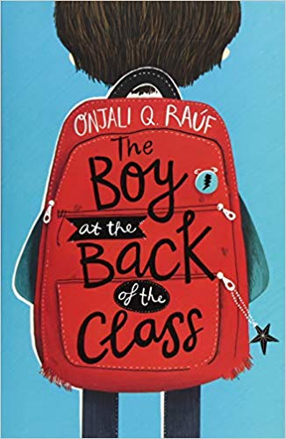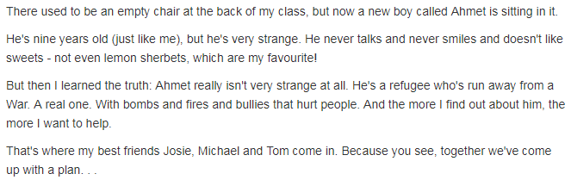

**Day eight**

1) Look at the front cover: make a prediction about the story by using the title and the images on the front of the book.

__________________________________________________________________________________________________________________________________________________________________________________________________________________________________________ **(2 marks)**

2) Read the blurb. Clarify what a refugee is.

**____________________________________________________________________________ (1 mark)**

3) What impression do you get of the character Ahmet from the blurb?

______________________________________________________________________________ **(1 mark**)

4) What do you think the plan could be that they have come up with?

_________________________________________________________________________________________________________________________________________________________________________(**2 marks)**

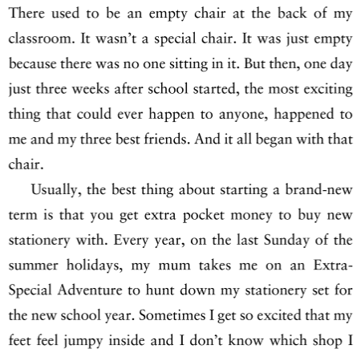

Read the extract of chapter one, **‘The empty chair.’**

4) What do you think the most exciting thing that could ever happen was**?**

________________________________________________________________(1 mark)

5) Why would the narrator get extra pocket money at the start of a brand new term?

________________________________________________________________ (1 mark)

6) What impression do you get of the character who is telling the story?

________________________________________________________________________________________________________________________________________ (2 marks)

**Grammar focus**

**7) Why has the author used a dash in the final part of the extract? _________________________________________________________________________________________________________________________________________(1 mark)**

**8) Find and copy a subordinate conjunction in the text.**

**_______________________________________________(1 mark)**

**9) Find an adverb in the text.**

**__________________________________________________ (1 mark)**

**(1 mark)**

