

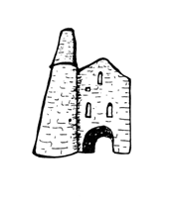**St Day and Carharrack Communuity School.**

44 Club

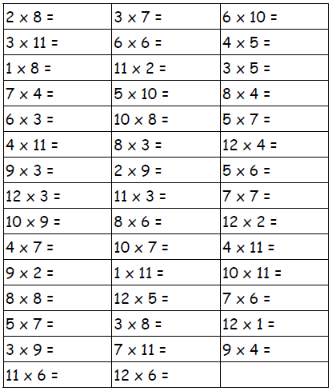Name:___________________ Date:________