2nd January 2023 Opal Class

Dear Families,
WELCOME TO THE YEAR 2023 EVERYONE! Happy New Year! I hope everyone had a joyous Christmas, rested and raring to go for the new year ahead! It is lovely to be back with some sense of normality again I have to admit.
So, here we go with an exciting Spring term ahead. Our main topic this term, ‘The World around Us’, focusses on the seasons Winter and Spring. Your children are fascinated by ice so this term we will do several science investigations based on the melting and freezing of ice and water. Through the term we will focus on the following Early Learning Goals by comparing the environments, St Day and Antarctica, and what and who lives in these places:
- Describe their immediate environment using knowledge from observation, discussion, stories, non-fiction texts and maps;
- Know some similarities and differences between different religious and cultural communities in this country, drawing on their experiences and what has been read in class;
- Explain some similarities and differences between life in this country and life in other countries, drawing on knowledge from stories, non-fiction texts and – when appropriate – maps.
A sample of some of the focussed texts this half term will include, Biscuit Bear (Mini Grey), Penguin Small (Mick Inkpen) and Blue Penguin (Petr Horacek):
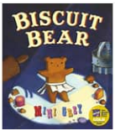
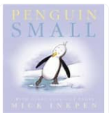
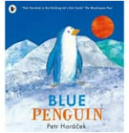

We are lucky to welcome Jenny Crow from the Cornwall Music Service Trust this Spring term who is going to lead in some music workshops with the children. We are aiming to present this learning to you at the end of the Spring term.
Further exciting learning opportunities available to us this term also include:
- Tuesday 10th January - A Hindu workshop with Daya
- Tuesday 31st January - Farm and Country Trailer visit
- PE with Mr Ayre
As always I will continue to keep you updated throughout the term on weekly learning and how you can support your children at home.

Activity of the week to try at home!
This term I am going to trial a borrowing system whereby you can borrow some of the games we use in school to take home and play. During the holiday clear-out I found lots of spare games floating around. Every Monday I will supply a green box of games/worksheets which you can take home for the week to support learning at home. I will add to this throughout the term listening to your feedback on how successful this is. I will also continue to add activities on the newsletters, so please also look out for these.
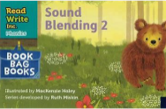
Activities this week: PLEASE work on all RWInc letters learnt in the previous term including common exception words below. I will endeavour to send out the next set of RWInc books in children’s Red book bags this week.
Common Exception words: the I to love

New Read Write Inc sounds to learn this week:
RWInc sounds learnt: m a s d t I p n p g o c k u b h l f r j v w qu y z x th sh ch
We have completed all the ‘single’ set one sounds including ‘special friends sh, ch, th, ng, nk’.
Please support your children with this at home as much as you can, especially if they unfortunately missed some time off school through sickness. The more you do at home, the more confident they will be in school.
Please follow both these links to watch at home for both letters sound reading lessons:
sh https://schools.ruthmiskin.com/training/view/gY32MUtz/q0dWeOLo
th https://schools.ruthmiskin.com/training/view/l9ZdQ9WA/2GGOQihX
ch https://schools.ruthmiskin.com/training/view/9BQbOweL/dIa7BcUa
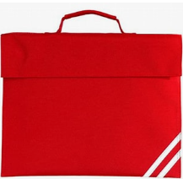
Red Book Bags
Please can all children bring their book bags into school every day. Now we are sending the RWinc books home it is vital all children have these to transport these backwards and forwards to and from school safely. School has invested a lot of money sourcing these books to match the learning happening in school specifically for RWInc so we appreciate your co-operation with this. RWI books must be looked after to avoid a charge to replace missing or damaged books Thank you!
I look forward to working with you all in this new year 2023. Please, if you ever have any concerns, do not hesitate to ask for support!

Miss Viv Horne Opal Class

