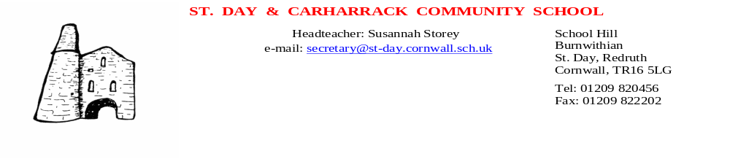

September 7th 2018

Dear Parents and Carers

Please find your child’s curriculum overview and welcome class letter in their book bags.

To enable us to update your details for our records please find attached the following forms to be completed and returned by Monday 10th September (as stated in the Welcome Letter) :

-Data Collection Form to check and update details or New Joiner Form
-Free School Meals and Pupil Premium Application – please complete and we will check this for you
-Trip Consent Form 2018-2019
-Photographic/Video Consent Form – this will cover your child for their school career
-Internet Access Form – this will cover your child for their school career
-Free After School Clubs Form – sign up required.

We will be very grateful if you can return all six forms with the checklist below as a matter of urgency. This will support us with the safety of your child and save Mrs Hill a huge amount of time in chasing late forms and lost forms. Your child will then be able to access all areas of the curriculum.

Yours sincerely

Susannah Storey
Headteacher

---------------------------------------------------------------------------------------------------------------
Consent Forms:
Child Name:

Year Group:

Data Collection Form/New Joiner Form □
Pupil Premium Form □
Trip Consent Form □
Photographic/Video Consent Form □
Internet Access Form □
Clubs Form □

